User Guide for VA Applicants
One Stop Shop [ERA-DRO-010]

 | Drafted by | Validated by | Approved by
Name | Intrasoft International S.A. | Spilios Vergopoulos | Nikolaos Pappas
Position | Contractor | Business Analyst | Project Manager
Date
Signature

Document History

Version | Date | Comments
0.52 | 15/02/2019 | Initial version
0.60 | 02/05/2019 | Update

Table of Contents
1 Introduction 3
1.1 The One-Stop Shop (OSS) 3
1.2 Purpose and scope of this document 3
2 General functionality 4
2.1 Register as applicant 4
2.2 Sign in and main applications page 7
2.3 Update user profile information 9
2.4 Forgot/Change password 9
3 Prepare a VA application 12
3.1 Create a new application 12
3.2 Application description 14
3.3 Conformity assessment bodies 16
3.4 Authorisation details 17
3.5 Documentation 21
3.6 Mapping tables 23
3.7 Sign & submit application 24
3.8 Share application 25
4 Prepare a VA pre-engagement (PE) application 26
4.1 Create a new application 26
4.2 Pre-engagement description 27
4.3 Intended Authorisation Details 29
4.4 Documentation 32
4.5 Sign & submit application 35
4.6 Share application 36
5 My work 38
6 Application Details Screen 39
7 Communication between applicant and assessment team-Issues 46
7.1 Update an application file 46
7.2 Create issue by the applicant 47

Introduction

The One-Stop Shop (OSS)
The One-Stop Shop (OSS) is an information and communication system that supports the Applicants, the European Union Agency for Railways (ERA) and the National Safety Authorities (NSAs) in performing their tasks related to Single Safety Certifications (SSC), Vehicle Authorisations (VA) and ERTMS trackside approvals (ERTMS.TA), as defined in the 4th Railway Package (4RP) set of legislative texts.
Detailed information in regards to the VA processes can be found on the ERA website: Vehicle Authorisations (VA).
The OSS is accessible on this url: https://oss.era.europa.eu
It is recommended to use an updated Google Chrome or Mozilla Firefox browser, as using others might result in poor performance or errors.

Purpose and scope of this document
This User Guide for VA applicants contains all essential information for the user to make use of the system functionality, as it includes a description of the detailed features and capabilities, and step-by-step procedures.
For this version of the document (v0.60) the following functions are available to the users:
- User (applicant) registration;
- Creation and submission of VA applications;
- Sharing of applications with other users;
- Management of the user profile.

General functionality

Register as applicant
Any applicant must self-register in the system in order to become a user. In the Sign In page shown in Figure 1, select the option “Create account”.
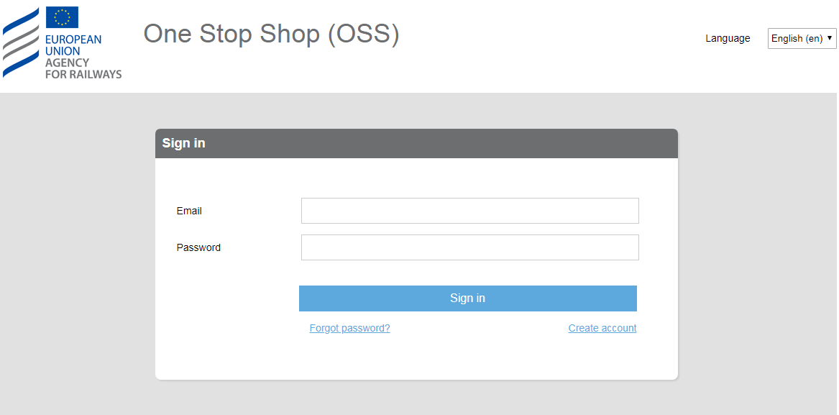
Figure 1: Sign in
The system then displays the page “Create Account”, as in Figure 2.
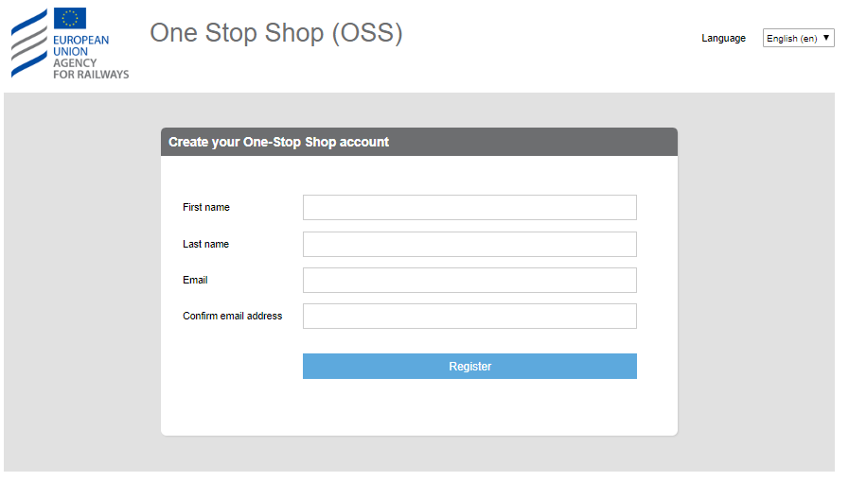
Figure 2: Create account
The user must provide “First name”, “Last name”, “Email”, “Confirm email address” and click on the “Register” button.

A message informs the user that the information entered is saved and an email is sent to the provided email address with instructions on how to set a password for the account, as shown in Figure 3. The user can then close the page.
IMPORTANT! The user is invited to read the Terms and Conditions before proceeding with the next steps. The user shall not proceed with the next steps if he/she does not agree with the Terms and Conditions and he/she shall contact the Agency. The Terms and Conditions details the contractual relationship between the Agency and the user of the system.
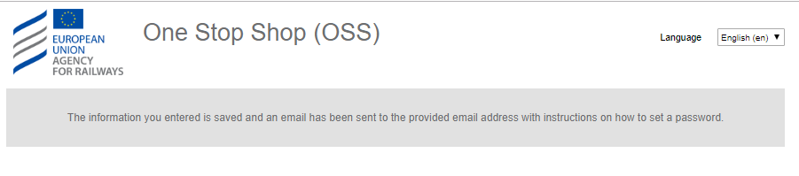
Figure 3: Message after successful registration
When the user receives the email, as illustrated in Figure 4, the user has to follow the provided link to set the password, shown in Figure 5.
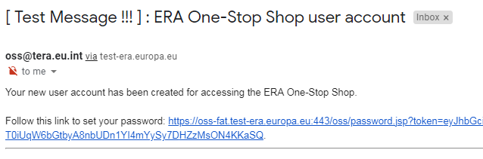
Figure 4: Registration email
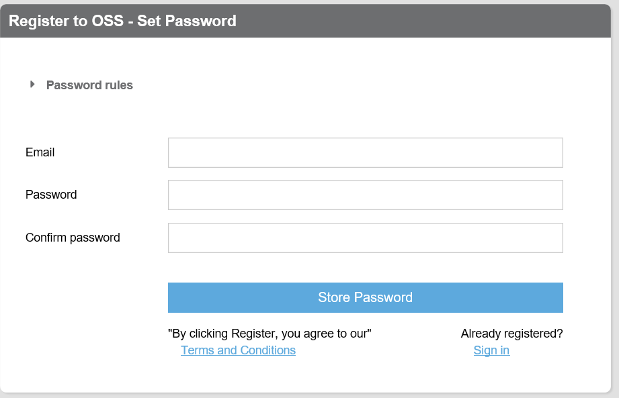
Figure 5: Setting a password
The user must provide “Email”, “Password”, “Confirm password” and click on the “Store password” button.
In order to set a correct password the user must follow the password rules:
- Passwords should not contain either your First name or your Last name;
- The password must be at least 8 characters long;
- The password should contain at minimum 3 out of :
  - 1 uppercase
  - 1 lowercase
  - 1 digit (0 to 9)
  - 1 special character (~!@#$%^&*_-+=`|\(){}[]:;"',.?/)
If the user did not follow the above rules or if passwords do not much then the system displays the appropriate error message as shown in Figure 6.
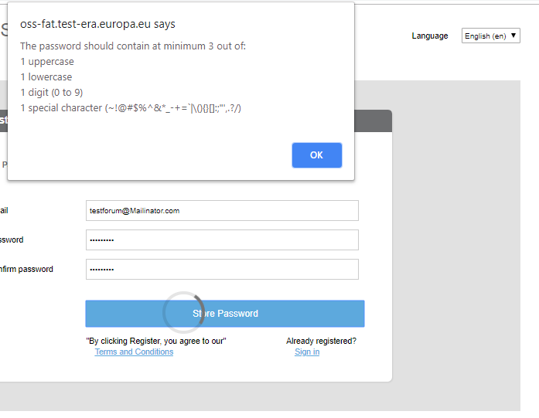
Figure 6: Error message for the password rules
After successful completion of the above the user is informed by the system, as displayed in Figure 7. The user can close the page.
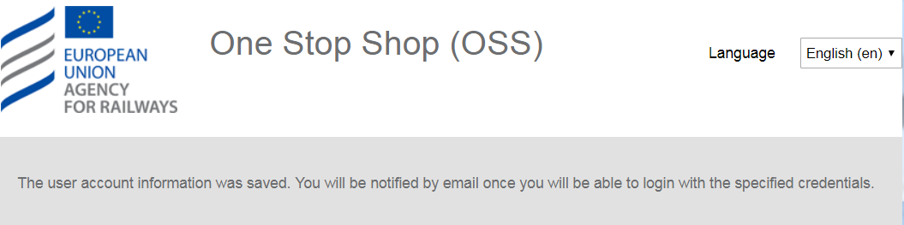
Figure 7: Successful setting of a password
The user will receive an acknowledgement of the account creation by email, within a maximum period of 15 minutes, in order to be able to sign in as shown in Figure 8.
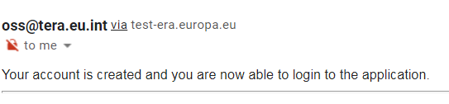
Figure 8: Acknowledgment of user creation

Sign in and main applications page
Only registered users are able to sign into the system (refer to section 2.1). In the landing page of the OSS shown in Figure 9, insert “Email” and “Password” and click on the “Sign in” button.

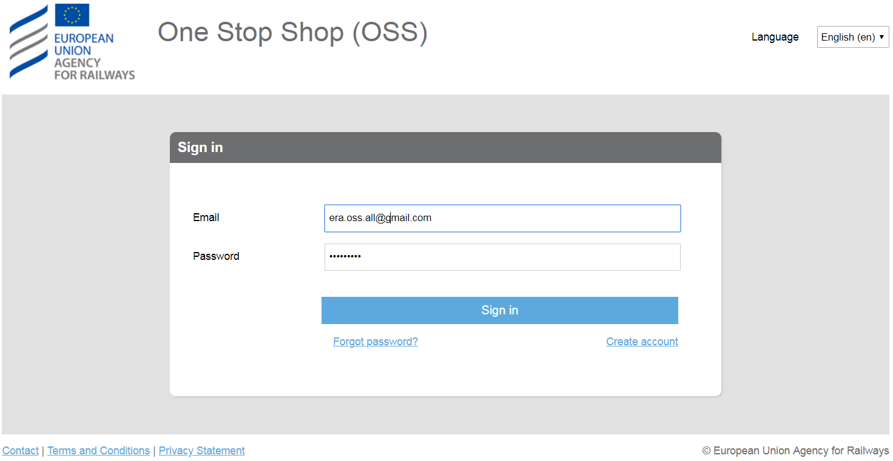
Figure 9: Sign in
The user, in addition, may select an alternative language for the User Interface (UI) than the English (default), by choosing one of the available languages as are found in the “Language” drop down list.
On successful sign in, the system will display the applications list for the VA domain, as shown in Figure 10.
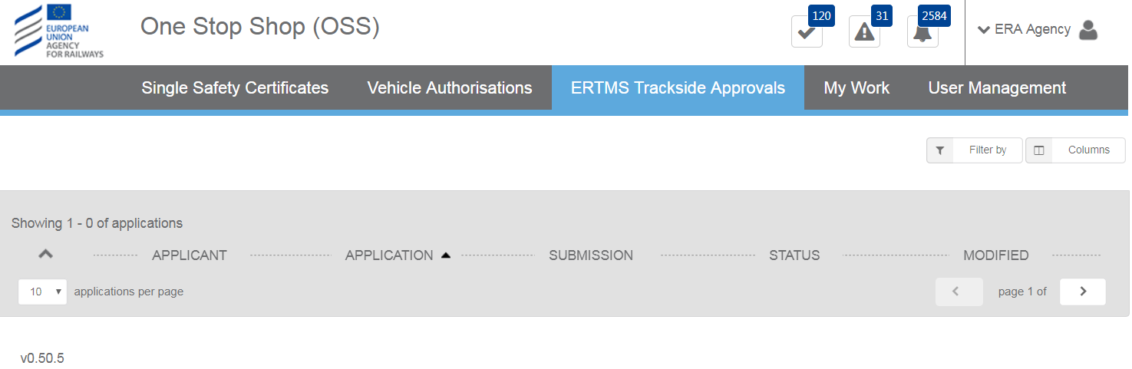
Figure 10: Main page – List of applications
The system displays applications in the form of a list, for which there are features for paging (go to next or previous page, display x items per list), selection of columns to display and filtering/sorting, as shown in Figure 11 and Figure 12.
Figure 11: Paging
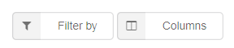
Figure 12: Filtering and Column selection
Additional navigation and functions are offered through the menu at the top right corner as shown in Figure 13.
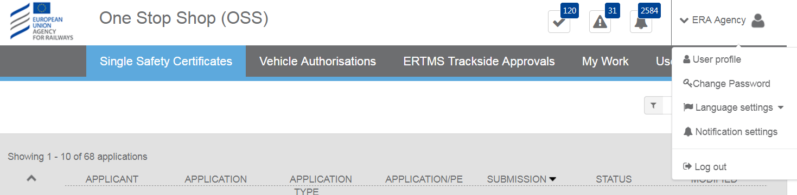
Figure 13: Menus and user actions
- User profile option allows for navigation to the user profile page (see section 2.3).
- Change password option allows for the password to be reset (see section 2.4).
- Language settings allow for the selection of your preferred language.
- Log out allows disconnection from the system. Upon successful logout the system displays the “Sign in” page, as shown in Figure 9.
The items below are also accessible when the user selects the menu option “My Work”.
Issues as shown in Figure 14, allow the user to see the list of issues across the applications.
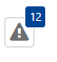
Figure 14: Issues button
Notifications as shown in Figure 15, allow the user to view all the notifications across applications.
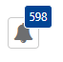
Figure 15: Notifications button

Update user profile information
Update user profile functionality, allows a user to update or insert new information to their user account, as shown in Figure 16.
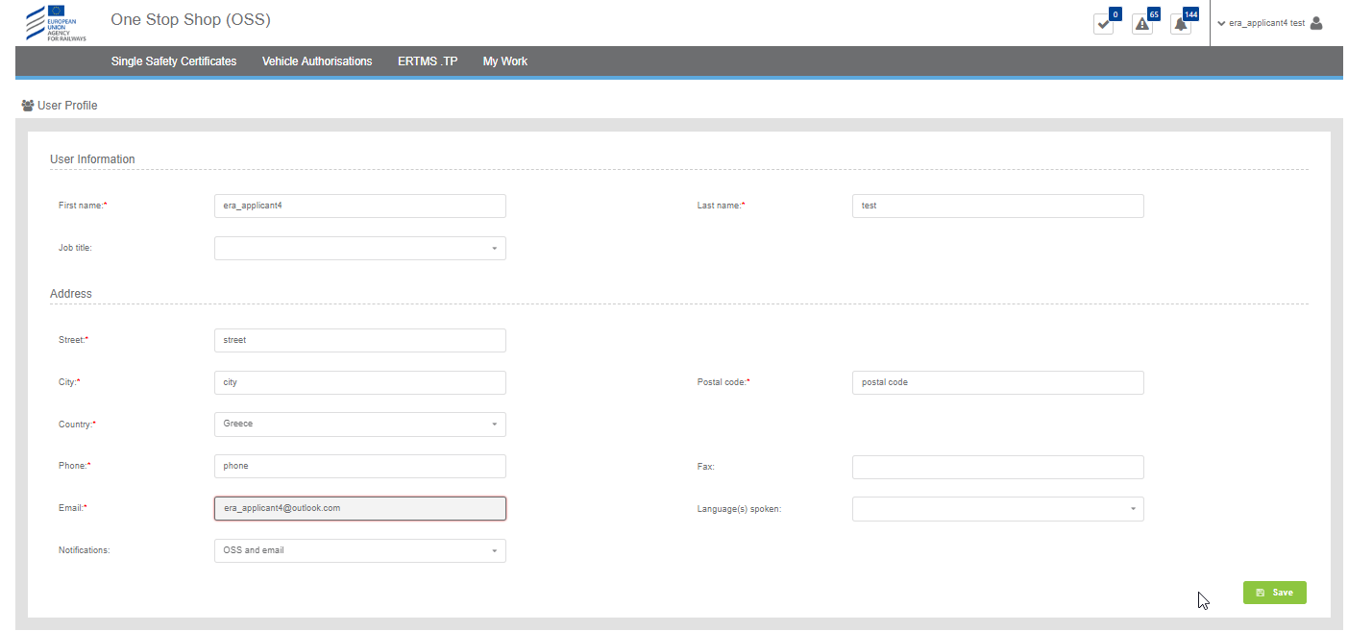
Figure 16: Update Profile
The user may insert and/or update any information in the form and click on the “Save” button. All fields marked with a red asterisk are mandatory and have to be filled by the user in order for the information to be saved.
It is recommended that users, after their first sign in, view and update their user profile, in order to ensure the correct information is depicted and in addition make selection for languages spoken and selecting the way notifications are sent.

Forgot/Change password
All users can request password reset in case that the password has been forgotten or for any other security reason. From the “Sign in” page select “Forgot password?”. The system displays Figure 17 “Reset your password” and allows the user to enter the registered email in the fields “Email” and “Confirm your email”.
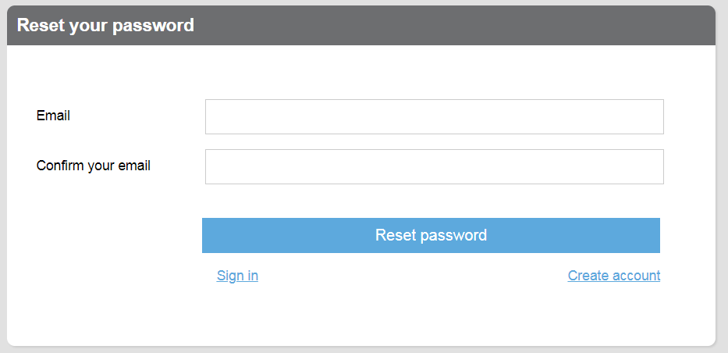
Figure 17: Reset your password
By selecting “Reset password”, the system displays the message shown in Figure 18 “Password change notification” and at the same time send an email to the user, with instructions on how to reset the password, as shown in Figure 19. The user can then close the page.
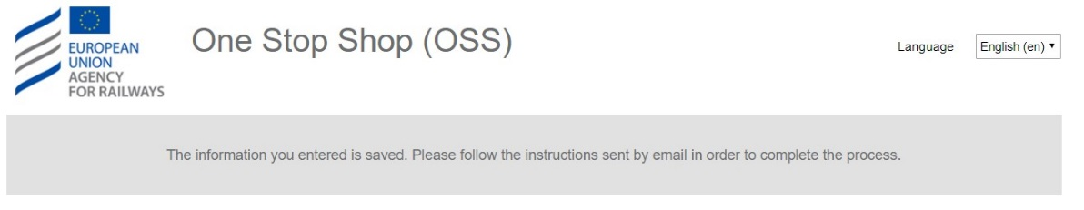
Figure 18: Password change notification
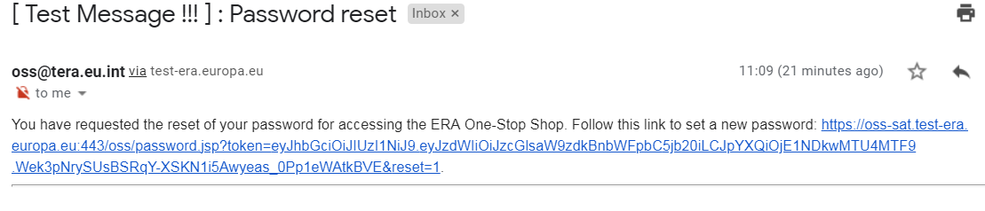
Figure 19: Password change email
The rest of the steps are similar to those followed for the initial registration of the user. Following the link in the email, the user will set the password and the system will send the password updated notification as shown in Figure 20, concluding the “forgot password” process.
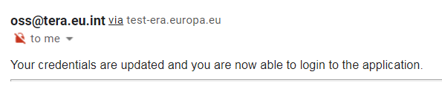
Figure 20: Password change confirmation
In a similar manner the user may change the password, whilst signed in by selecting “Change password” in the user actions menu as shown in Figure 13. The system then displays Figure 21, asking the user to provide a new password and confirm it. By selecting “Reset” a confirmation message is displayed informing of the change of password as shown in Figure 22, and a notification is sent to the email account of the user, similar to what is shown in Figure 20.
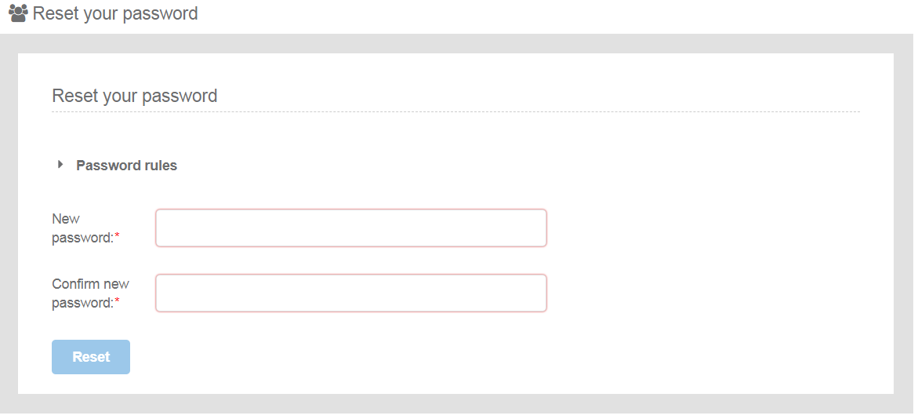
Figure 21: Change Password
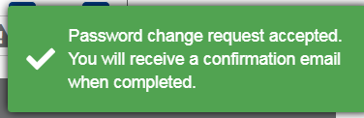
Figure 22: Change Password notification

Submit a VA application

Create a new application
This section explains how an applicant user of the system can create and prepare a VA application file.
The available vehicle authorisations cases are:
- First Authorisation
- New Authorisation
- Extended area of use authorisation
- Renewed vehicle type authorisation
- Authorisation in conformity to type
- First Authorisation and Authorisation in conformity to type
- New Authorisation and Extended area of use authorisation
For detailed description on the above cases, it is recommended that the reader refers to the relevant Regulation and Directives of the EU and the Practical Arrangements as describe in the agency’s website: Vehicle Authorisations (VA).
Only applicant users can create applications. In the “Main page - Applications list”, select “New” and then “Apply for a vehicle authorisation” as shown in Figure 23.
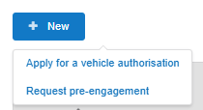
Figure 23: Create Vehicle Authorisation application
The system displays a wizard, splitting in steps the creation of an application file in a form of a status bar, showing the steps that must be completed to submit the application as shown in Figure 24. By selecting “Hide progress bar” the wizard is hidden.
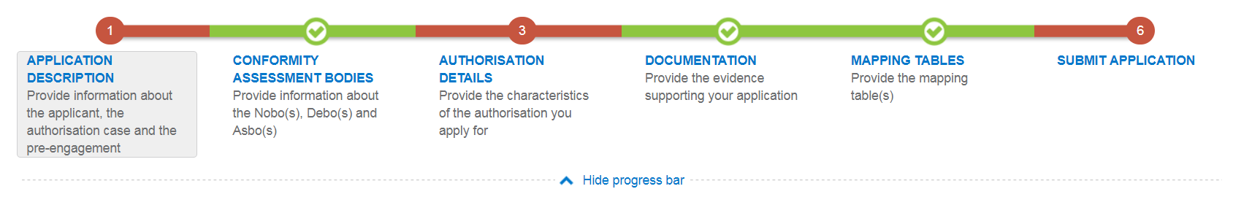
Figure 24: Progress bar of a Vehicle Authorisation
The colour of the progress bar per step indicates if the application is incomplete or there are mandatory fields missing (red colour) or if it is completed and verified by the system (green colour).
There are a number of fields in each step that are flagged as mandatory, having a red asterisk (*) in their label as shown in Figure 25.
Figure 25: Mandatory fields
In addition for every field a tooltip is displayed, with relevant information on the meaning the value expected for the field as shown in Figure 26.
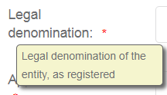
Figure 26: Tooltip information
For all the mandatory fields the system expects the user to enter a value, and in case that any of them are not correctly filled by the user, the system identifies the field in error highlights it in red and displays the red alert icon as shown in Figure 27.
Figure 27: Alerts and fields in error
When a user will select to “Validate” the application in the last step of the wizard, if there are forms that are not correctly filled or there are required fields missing, the system displays the message shown in Figure 28, and the relevant wizard step has red colour. The user must return to the relevant step and correct all errors.
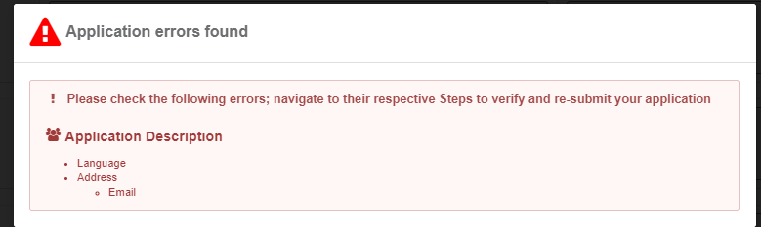
Figure 28: Error message validating the submission of an application
The user might select to navigate away from the wizard and continue the application preparation later. In this case the system allows the user to modify the draft application as found in the Application List, shown in Figure 29, by clicking the “View” button.
Figure 29: Applications list with a draft application
The Applicant follows the below steps to create an application:
- Application Description
- Conformity Assessment Bodies
- Authorisation Details
- Documentation
- Mapping Tables
- and finally, Submit Application
The information contained in all the above forms stems from the Annexes of the Practical Arrangements found in the (Commission Implementing Regulation (EU) 2018/545 of 4 April 2018 establishing practical arrangements for the railway vehicle authorisation and railway vehicle type authorisation process).

Application description
In this first step of the wizard as shown in Figure 30, the Applicant must fill in information in regards to Applicant’s information, Contact person’s information and details on the Authorisation case.
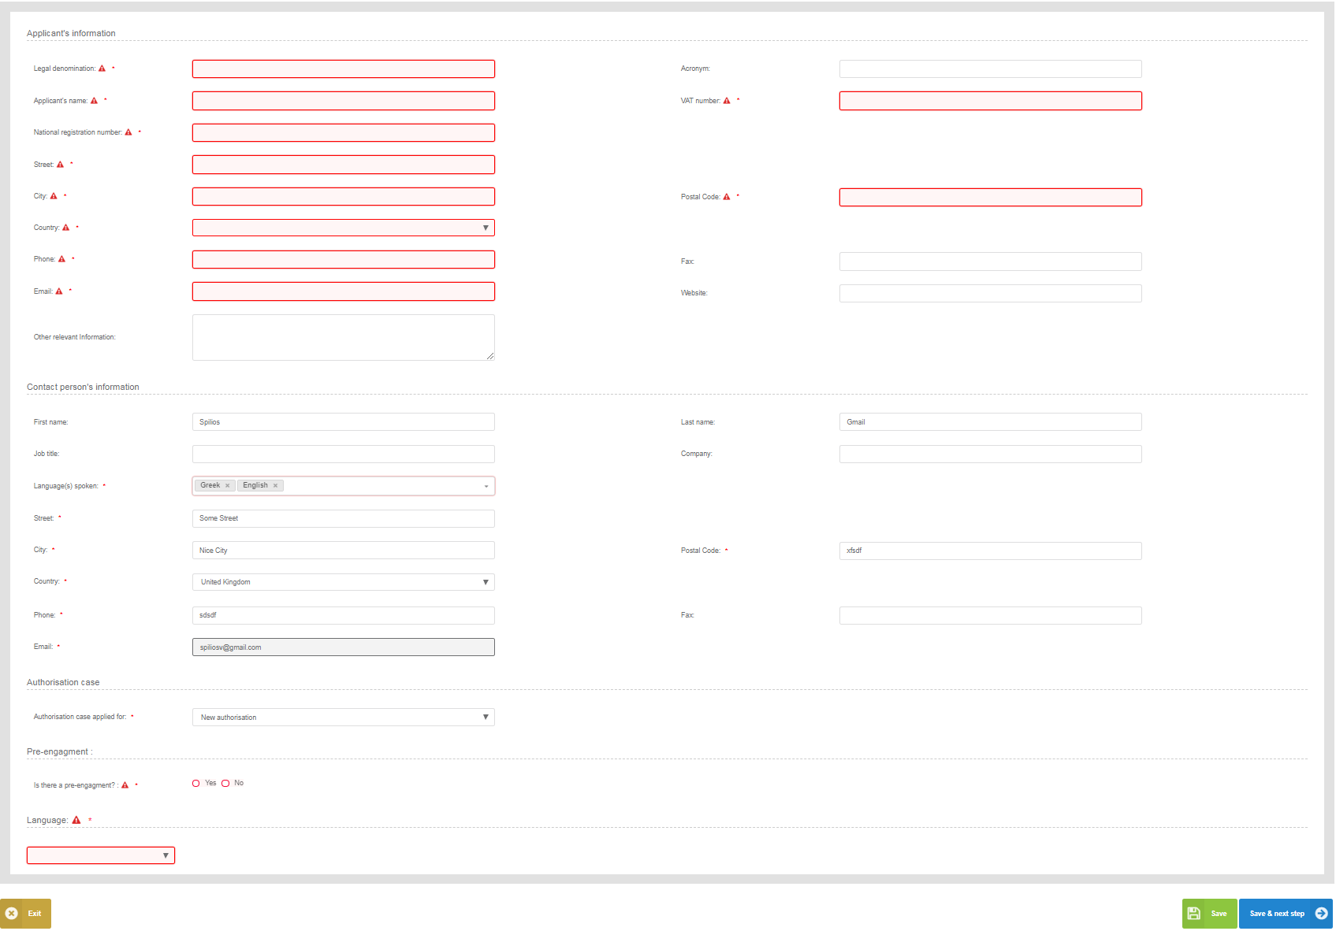
Figure 30: Application Description
The Applicant must provide the Applicant's information and address details. Contact person information is already filled in with information that exists as part of the user profile and allows for editing by the user. All mandatory fields are clearly marked by red asterisk (*).
In the Authorisation case part the user is asked to select the “Authorisation case applied for” as shown in Figure 31 and according to the available authorisation cases.
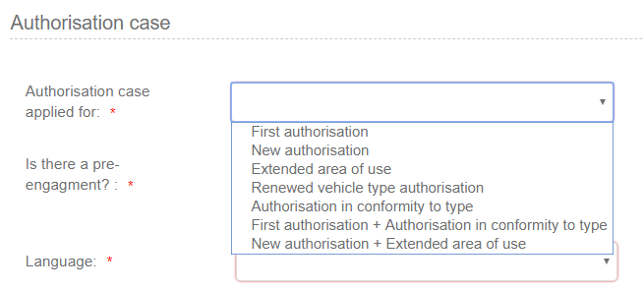
Figure 31: Authorisation Case
The system also displays the option to link this application to a pre-engagement. If the user selects "Yes" then the system requires the pre-engagement id as shown in Figure 32.
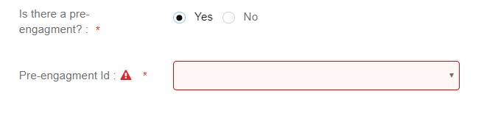
Figure 32: Pre- engagement id
The Applicant must also select the Language, in which all Formal Communication and Decisions/Authorisations will be delivered, shown in Figure 33.
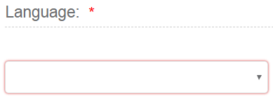
Figure 33: Language
To save and move to the next step of the application file wizard, the applicant may select "Save and next step" button, shown in Figure 34.
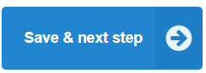
Figure 34: Save and next step
To stop editing the application and go to the main menu “Exit” button is selected, shown in Figure 35.
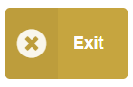
Figure 35: Discard Application-Exit button
To save the application, the applicant clicks on the “Save” button.
Figure 36: “Save “button
If there is unsaved information a warning message is displayed to the user about loss of unsaved information.
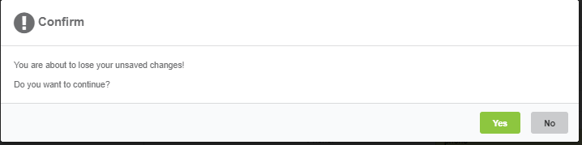
Figure 37: Warning message about unsaved information loss

Conformity assessment bodies
In this second step of the wizard as shown in Figure 38, the Applicant must fill in information in regards to Notified Body(ies), Designated Body(ies) and Assessment Body(ies) (CSM RA). None of these bodies are mandatory and for each one of them the applicant may add more than one.
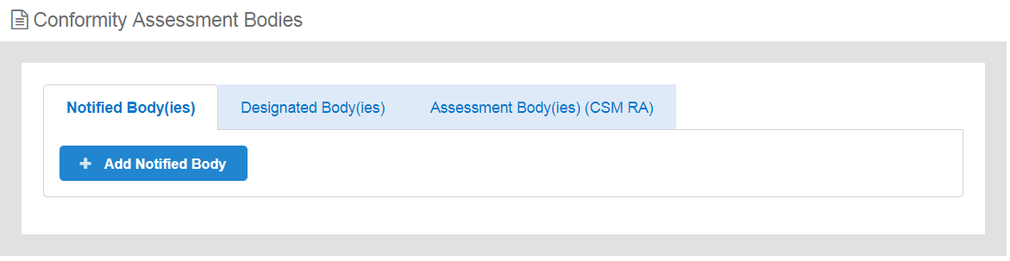
Figure 38: Conformity Assessment Bodies
When the applicant introduces any of the above bodies, then the system requires that the detailed information as shown in Figure 39 is provided.
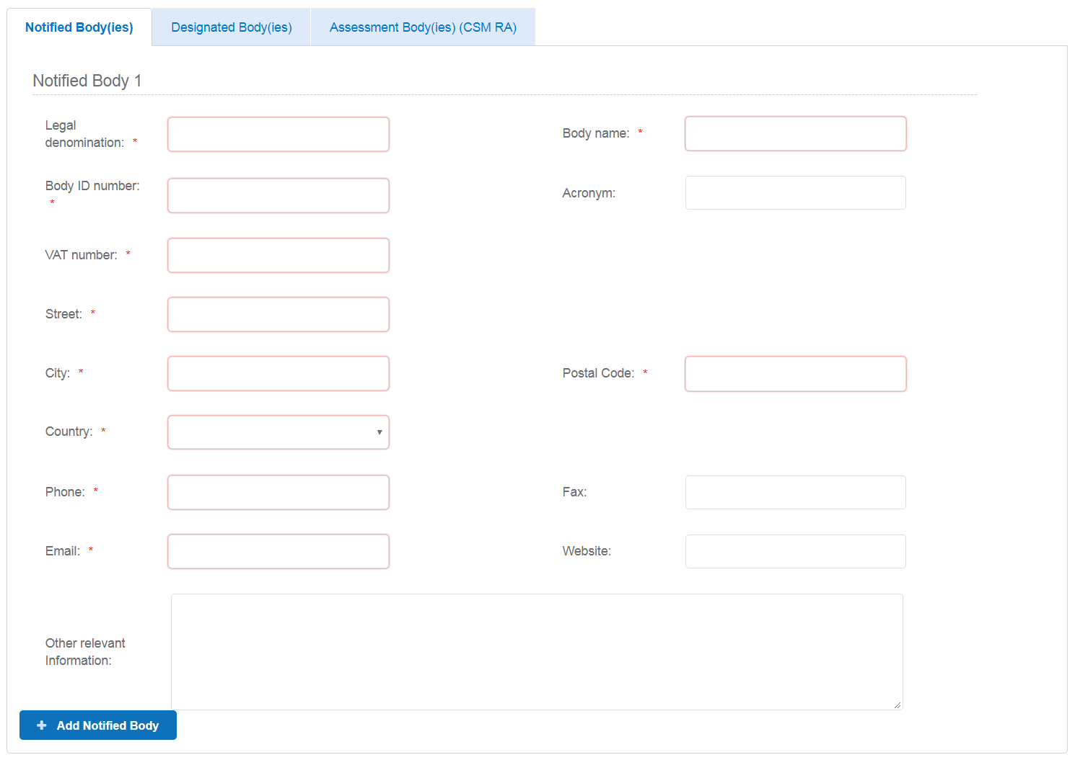
Figure 39: Conformity Assessment Bodies-Details
The applicant can remove any of the inserted bodies, by selecting the remove button as shown in Figure 40.
Figure 40: Conformity Assessment Bodies-Remove Body
The mandatory fields are clearly marked with red asterisk (*). To move to the next step "Save & next step" is selected as shown in Figure 34, the form is saved as shown in Figure 36. In addition the system allows the user to visit the previous step of the wizard by selecting “Previous step” button, shown in Figure 41.
Figure 41: Previous step

Authorisation details
In this step of the wizard the Applicant is asked to introduce information on a Type and/or Variants depending on the Authorisation case selected in the Application Description step as shown in Figure 42.
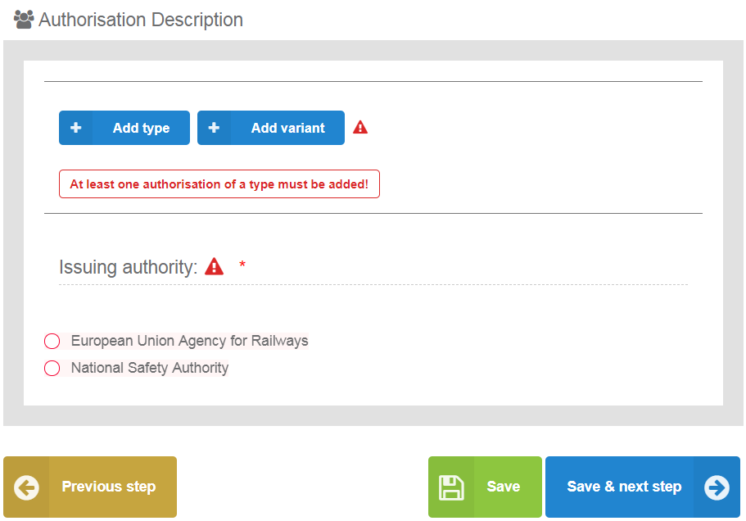
Figure 42: Authorisation Details step overview
The information required by the applicant to be introduced for all allowed Type and Variant(s) is based on the authorisation case requested, the full extent of which is shown in Figure 43. All mandatory information is marked with (*) and is required.
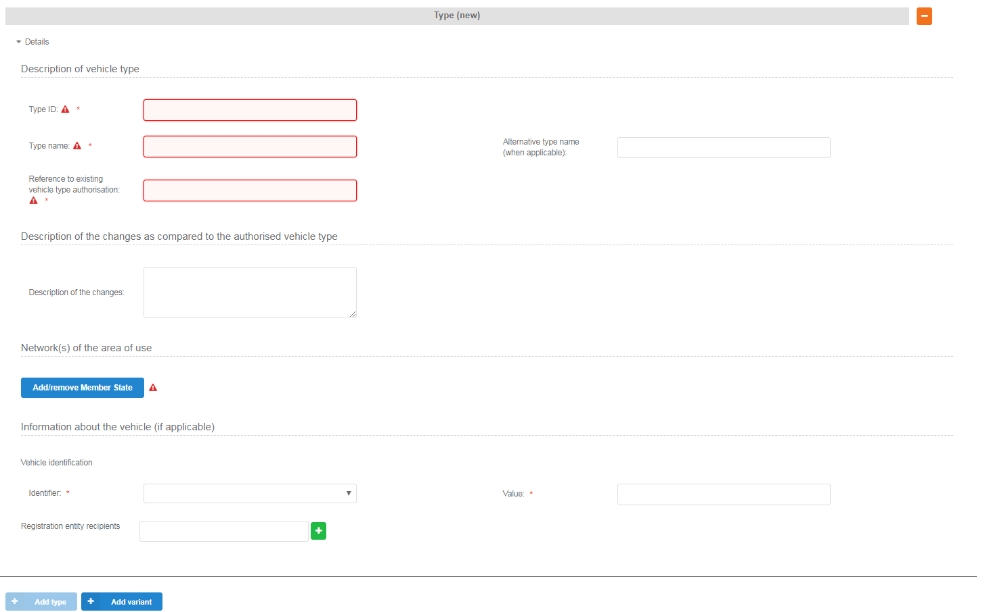
Figure 43: Authorisation Details for Type/Variant(s) in case of NEW authorisation
The applicant selects to fill-in the fields for Description of vehicle type/variant and select at least one country by using the “Add/Remove Member state” button. The Member states are selected by radio buttons that can be activated and deactivated as shown in Figure 46. Select “Whole EU” when there is no national rule applicable to the vehicle and only the Agency needs to perform the assessment.
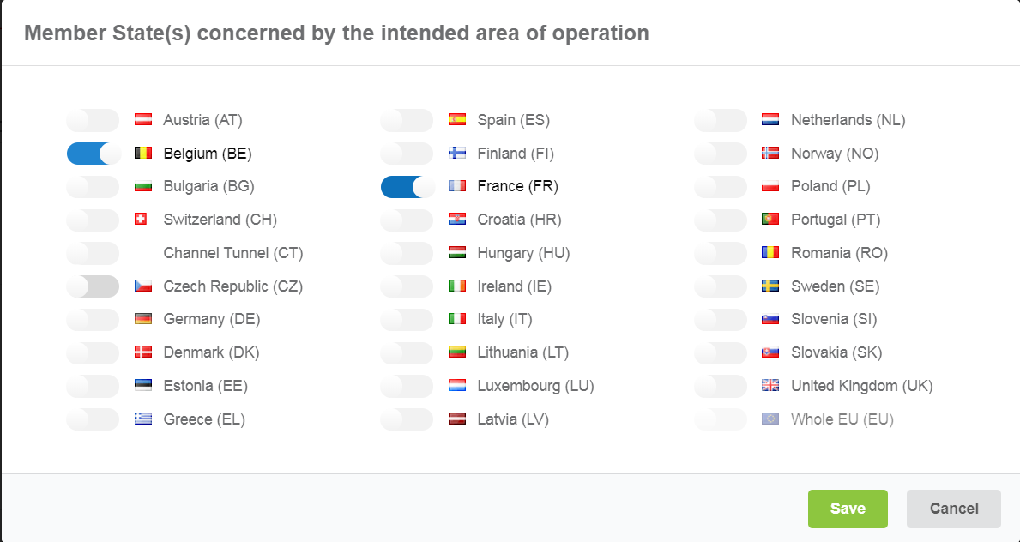
Figure 44: Member State(s) selection
After saving the selection, detailed information that need to be filled in (Network(s) and stations with similar network characteristics in neighbouring Member State(s)) about each member state is displayed as shown in Figure 45.
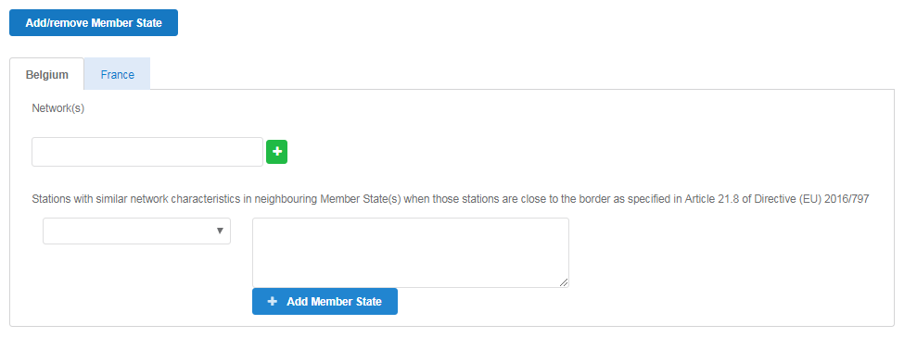
Figure 45: Authorisation Details – Member State details
The applicant may also introduce “Information about the vehicle”. For Vehicle identification the user may select an “Identifier” and introduce the value corresponding to the selected identifier. In addition a number of “Registration entity recipients” may be introduced, as shown in Figure 48. The registration entity recipients will be notified of the decision when it will be delivered to the Applicant.
Figure 46: Authorisation Details - Information about the vehicle
For the combined authorisation cases offered by the system, “First Authorisation and Authorisation in conformity to type” and “New Authorisation and Extended area of use authorisation” the user must introduce the required information for both authorisations requested, as shown in Figure 47.
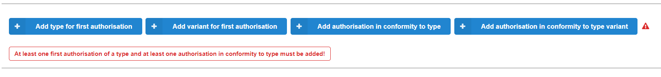
Figure 47: Authorisation Details – Combined Authorisation case for FIRST+CONF
Another authorisation case that deviates from the general path of filling the Authorisation details information is the “Authorisation in conformity to type” as shown in Figure 48. In such an authorisation there is no introduction of Members State details, but only the selection of related Member State(s). In addition the applicant may introduce a number of “Information about the vehicle(s) to authorise” section, in a similar manner as in the “Information about the vehicle” for all other authorisation cases, also relate this information to a single vehicle or a range, as shown in Figure 49 and add any Coded or Non-coded restrictions applied to the selected vehicle(s).
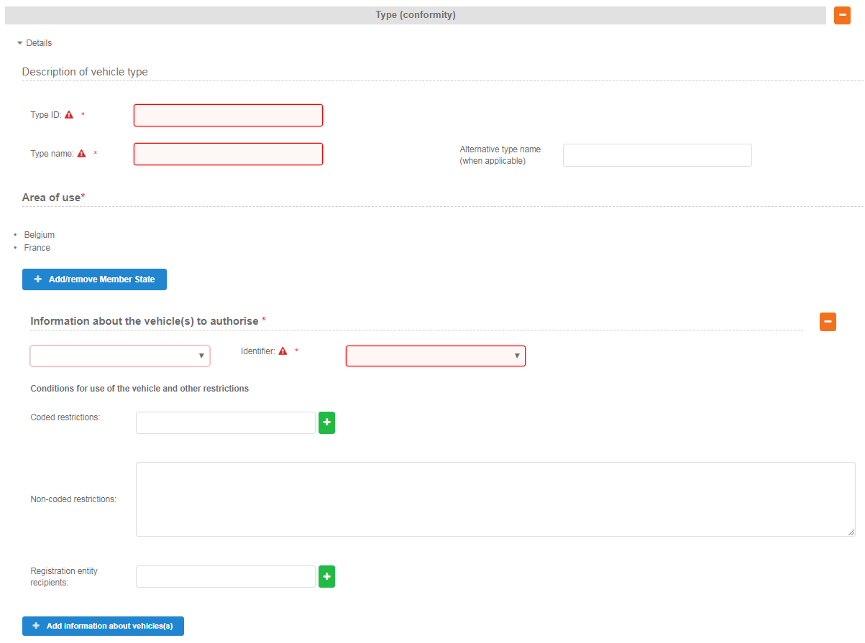
Figure 48: Authorisation Details - Authorisation in conformity to type
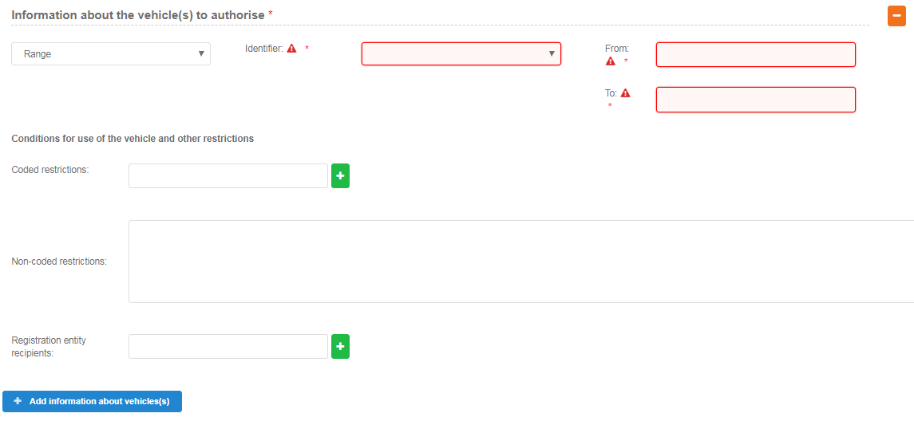
Figure 49: Authorisation Description- Range of vehicle(s) to authorise
The last step in this Authorisation details step is the selection of the “Issuing Authority”. If the Applicant has introduced a number of Member States, within the Type/Variant(s), then the system sets this value automatically to “European Union Agency for Railways”, as shown in Figure 50. The applicant may choose to use the “National Safety Authority”, only if all introduced Type/Variant(s) address one and the same Member State, in which case the Member State is the issuing authority.
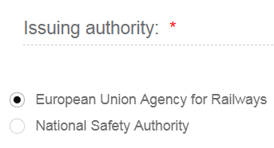
Figure 50: Issuing Authority
To move to the next step "Save & next step" is selected as shown in Figure 34, the form is saved as shown in Figure 36. In addition the system allows the user to visit the previous step of the wizard by selecting “Previous step” button, shown in Figure 41.

Documentation
In this step of the wizard as shown in Figure 51, the Applicant must provide the documentation relevant to the Authorisation case selected in the first step. The list of folders as appear in this step stem from Annex I of the implementing act (Commission Implementing Regulation (EU) 2018/545 of 4 April 2018 establishing practical arrangements for the railway vehicle authorisation and railway vehicle type authorisation process).
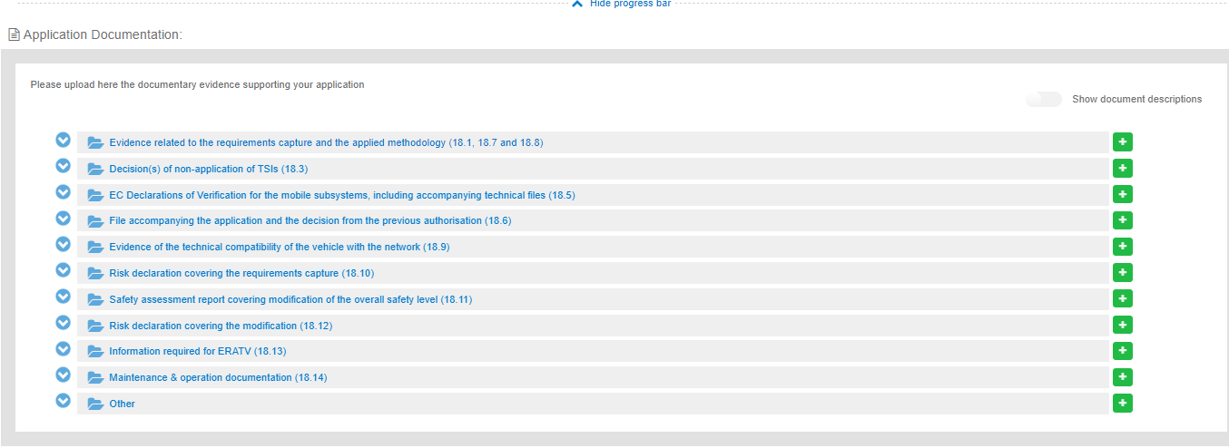
Figure 51: Application documentation
The Applicant can upload any documents needed for the application by selecting the "+" button relevant to each folder. Such action displays the Add file(s) page, shown in Figure 52 and allow the user to either select one or more files to upload from a specific folder on the user’s system as shown in Figure 55 or by drag and drop the file(s) in the “Drop your file(s) here” section. Please note that the system accepts as valid uploads the ones described in the File upload rules.
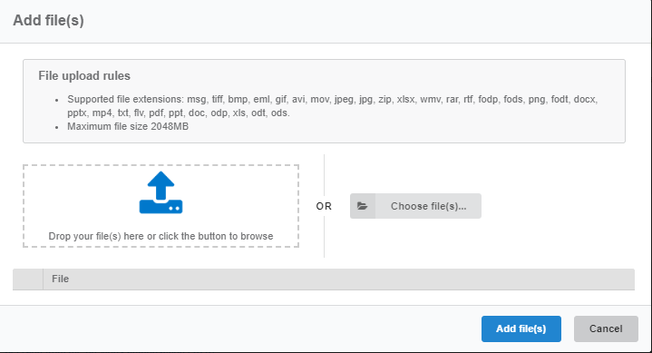
Figure 52: Add file(s)
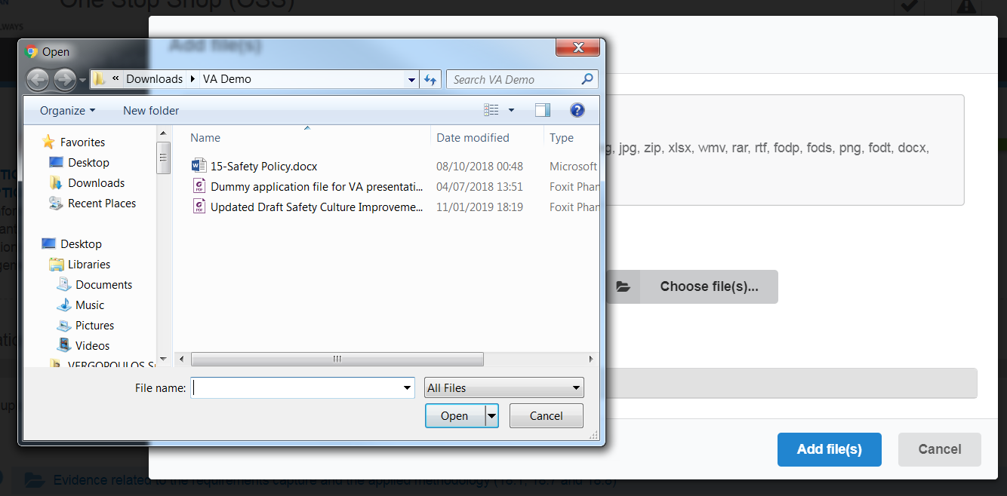
Figure 53: Choose file(s)
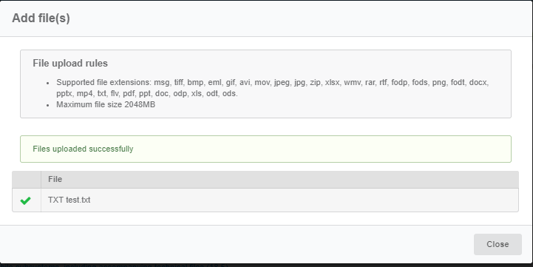
Figure 54: Successful upload
When selecting "Add file(s)" the file(s) selected by the user are uploaded and if successful the messaged displayed in Figure 54 is shown and the relevant file(s) appears in the relevant folder of documentation, as shown in Figure 55.
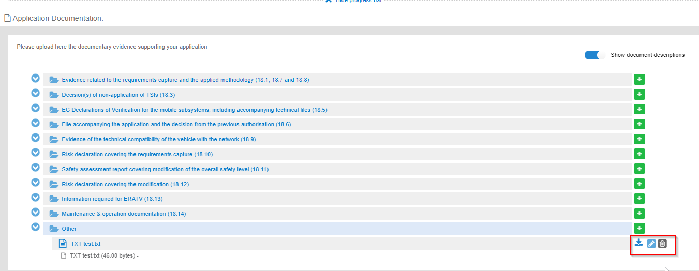
Figure 55: Uploaded file
The user can download and delete the document by using the relevant buttons on the right and also edit the title and the description of the uploaded file.
To move to the next step "Save & next step" is selected as shown in Figure 34, the form is saved as shown in Figure 36. In addition the system allows the user to visit the previous step of the wizard by selecting “Previous step” button, shown in Figure 41.

Mapping tables
In the Mapping Tables step of the wizard, the applicant is asked to reference the provided documentation in the previous step, to the assessment aspect set for each Authorising entity and NSA involved in the application, as shown in Figure 56. The assessment aspects are described in Annex II for the Authorising Entity and Annex III for each NSA, of the practical arrangements document (Commission Implementing Regulation (EU) 2018/545 of 4 April 2018 establishing practical arrangements for the railway vehicle authorisation and railway vehicle type authorisation process).
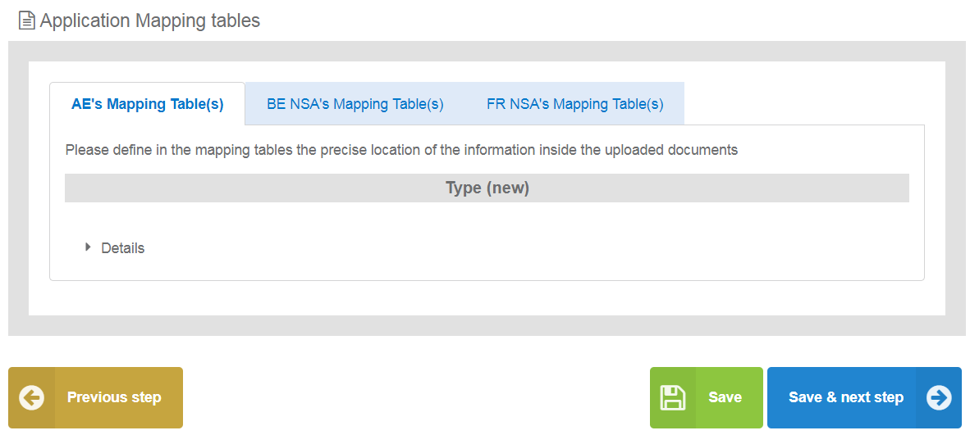
Figure 56: Mapping Tables wizard step
For every assessment aspect found in the mapping tables, the user is required to provide the reference from the documentary evidence, the reference with the selected document and a comment if applicable as shown in Figure 57. The user may reference more than one file for each assessment aspect, by using the “+”. It can be removed by using the “-”. The documentary evidence is a drop down list that includes all the folders and added files in the previous Documentation step.
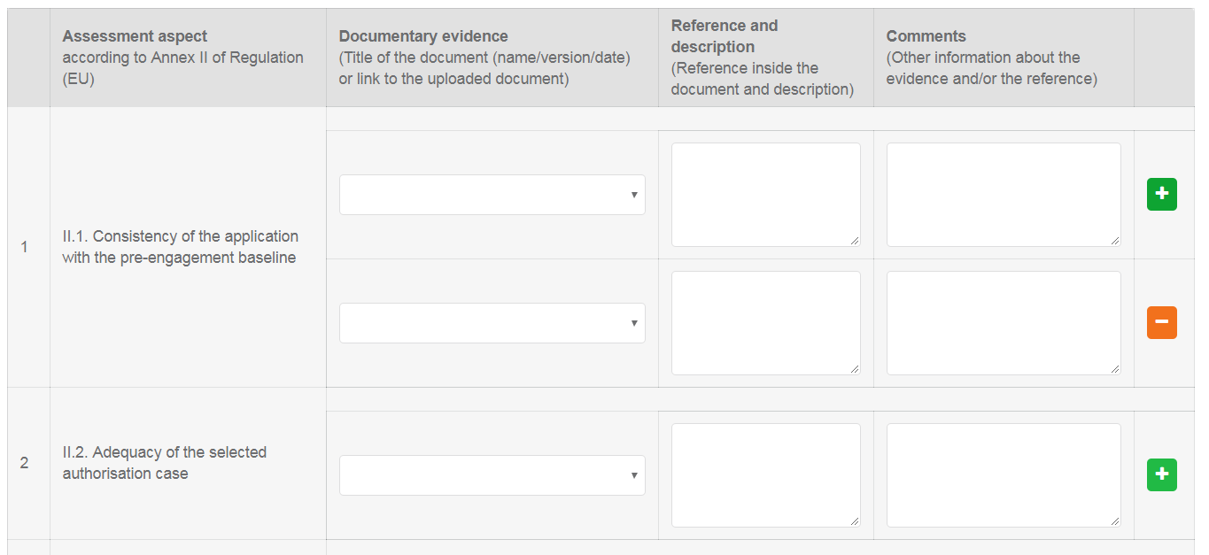
Figure 57: Mapping Tables wizard step
When the user is satisfied, may use any of the “Save”, “Save and Next” or “Previous” buttons.
To move to the next step "Save & next step" is selected as shown in Figure 34, the form is saved as shown in Figure 36. In addition, the system allows the user to visit the previous step of the wizard by selecting “Previous step” button, shown in Figure 41.

Sign & submit application
In this last step of the wizard the user can review the application form prior to submitting it, as shown in Figure 58.
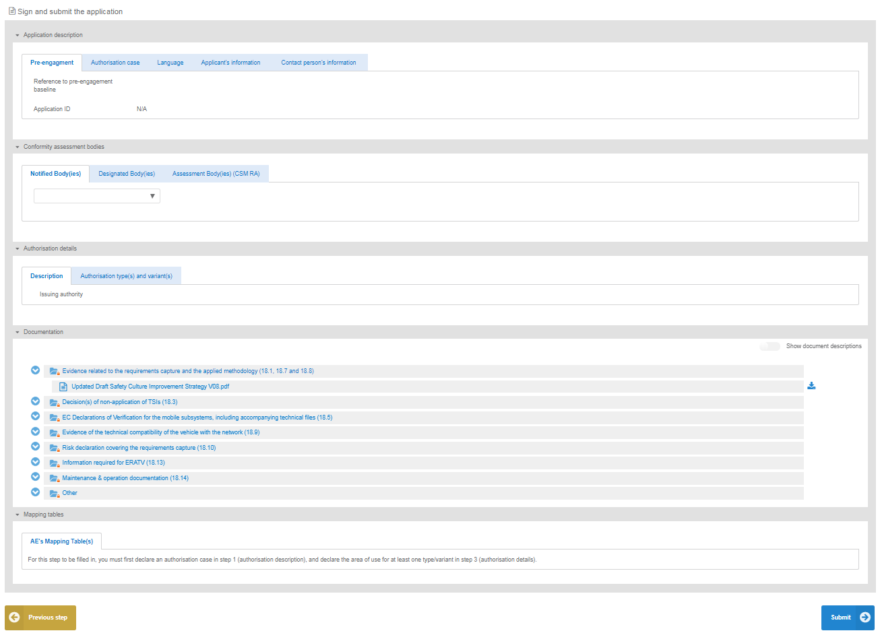
Figure 58: Review application
The application form is presented in read-only mode, any changes can only be made in the relevant sections of the application form. To go back to the previous step, select “Previous step”. To submit the application the user selects the "Submit" button.

Share application
In the “Main page – Application list”, select the option to share an application with another applicant user. Select option “Share application”, as shown in Figure 59, fill in the requested information in the popup window that is displayed, as shown in Figure 60, and finally select “Share”. A notification will be sent to the new application user.
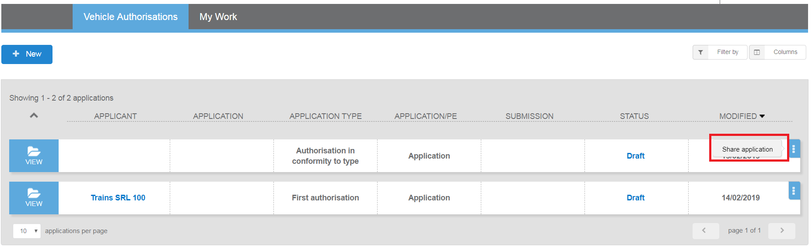
Figure 59: Share application
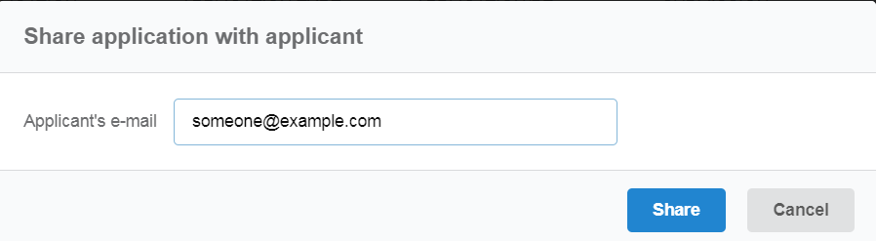
Figure 60: Share application - popup

Submit a request for VA pre-engagement (PE)

Create a new application
This section explains how an applicant user of the system can create and prepare a VA pre-engagement (PE) application file.
The available vehicle authorisations cases are the below and are the same as VA:
- First Authorisation
- New Authorisation
- Extended area of use authorisation
- Renewed vehicle type authorisation
- Authorisation in conformity to type
- First Authorisation and Authorisation in conformity to type
- New Authorisation and Extended area of use authorisation
For detailed description on the above cases, it is recommended that the reader refers to the relevant Regulation and Directives of the EU and the Practical Arrangements as describe in the agency’s website: Vehicle Authorisations (VA).
Only applicant users can create applications. In the “Main page - Applications list”, select “New” and then “Request pre-engagement” as shown in Figure 61.
Figure 61: Create Vehicle Authorisation pre-engagement application

The system displays a wizard, splitting in steps the creation of an application file in a form of a status bar, showing the steps that must be completed to submit the application as shown in Figure 62. By selecting “Hide progress bar” the wizard is hidden.
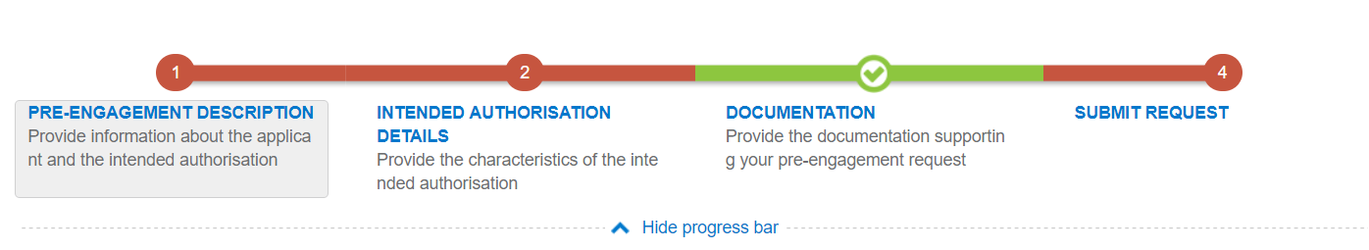
Figure 62: Progress bar of a Vehicle Authorisation PE
The colour of the progress bar per step indicates if the application is incomplete or there are mandatory fields missing (red colour) or if it is completed and verified by the system (green colour).
There are a number of fields in each step that are flagged as mandatory, having a red asterisk (*) in their label as shown in Figure 25.
In addition, for every field a tooltip is displayed, with relevant information on the meaning the value expected for the field as shown in Figure 26.
For all the mandatory fields the system expects the user to enter a value, and in case that any of them are not correctly filled by the user, the system identifies the field in error highlights it in red and displays the red alert icon as shown in Figure 27.
When a user will select to “Submit” the application in the last step of the wizard, if there are forms that are not correctly filled or there are required fields missing, the system displays the message shown in Figure 63, and the relevant wizard step has red colour. The user must return to the relevant step and correct all errors.
Figure 63: Error message validating the submission of an application
The user might select to navigate away from the wizard and continue the application preparation later. In this case the system allows the user to modify the draft application as found in the Application List, shown in Figure 64, by clicking the “View” button.
Figure 64: Applications list with a draft application
The Applicant follows the below steps to create an application:
- Pre-engagement Description
- Intended Authorisation Details
- Documentation
- and finally, Submit Request

The information contained in all the above forms stems from the Annexes of the Practical Arrangements found in the (Commission Implementing Regulation (EU) 2018/545 of 4 April 2018 establishing practical arrangements for the railway vehicle authorisation and railway vehicle type authorisation process).

Pre-engagement description

In this first step of the wizard as shown in Figure 65, the Applicant must fill in information in regard to Applicant’s information, Contact person’s information and details on the Authorisation case.
Figure 65: Application Description
The Applicant must provide the Applicant's information and address details. Contact person information is already filled in with information that exists as part of the user profile and allows for editing by the user. All mandatory fields are clearly marked by red asterisk (*).
In the Authorisation case part, the user is asked to select the “Authorisation case applied for” as shown in Figure 31 and according to the available authorisation cases.

The system also displays the option to link this application to a pre-engagement. If the user selects "Yes" then the system requires the pre-engagement id as shown in Figure 32.
The Applicant must also select the Language, in which the decision will be issued, shown in Figure 33.
To save and move to the next step of the application file wizard, the applicant may select "Save and next step" button, shown in Figure 66.
Figure 66: Save and next step
To stop editing the application and go to the main menu “Exit” button is selected, shown in Figure 67.
Figure 67: Discard Application-Exit button
To save the application, the applicant clicks on the “Save” button.
Figure 68: “Save “button
If there is unsaved information a warning message is displayed to the user about loss of unsaved information.
Figure 69: Warning message about unsaved information loss

Intended Authorisation Details
In this second step of the wizard as shown in Figure 70, the Applicant must provide the characteristics of the intended authorisation. Specifically, in this step of the wizard the Applicant is asked to introduce information on a Type and/or Variants depending on the Authorisation case selected in the Application Description step.

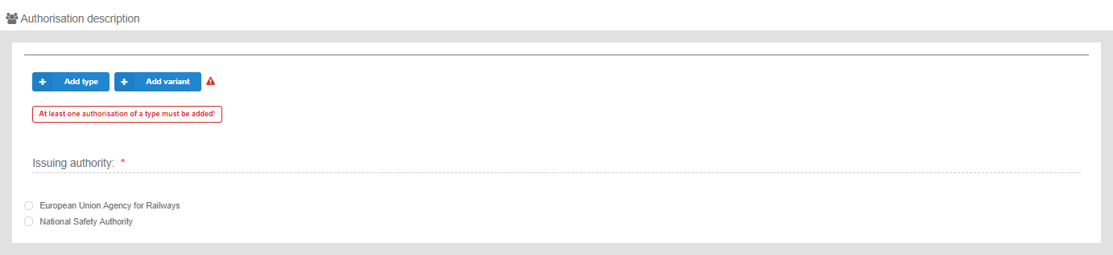
Figure 70: Authorisation Description

The information required by the applicant to be introduced for all allowed Type and Variant(s) is based on the authorisation case requested, the full extent of which is shown in Figure 71. All mandatory information is marked with (*) and is required.

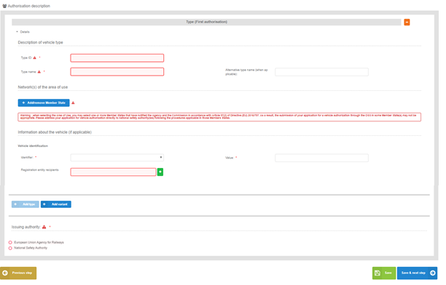
Figure 71: Authorisation Description for Type/Variant(s) in case of a New authorisation

The applicant selects to fill-in the fields for Description of vehicle type/variant and select at least one country by using the “Add/Remove Member state” button. The Member states are selected by radio buttons that can be activated and deactivated as shown in Figure 72 Select “Whole EU” when there is no national rule applicable to the vehicle and only the Agency needs to perform the assessment.
Figure 72: Member State(s) selection

After saving the selection, detailed information that need to be filled in (Network(s) and stations with similar network characteristics in neighbouring Member State(s)) about each member state is displayed as shown in Figure 73.
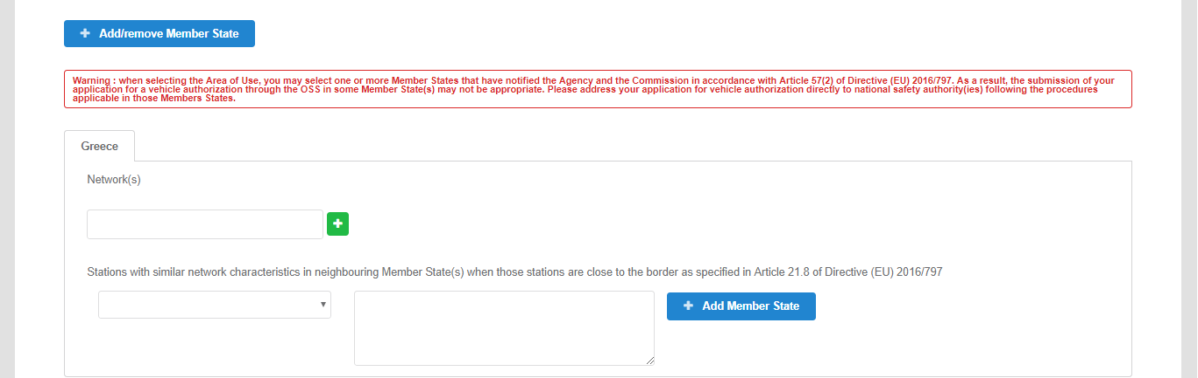
Figure 73: Authorisation Details- Member State details
The applicant may also introduce “Information about the vehicle”. For Vehicle identification the user may select an “Identifier” and introduce the value corresponding to the selected identifier. In addition, a number of “Registration entity recipients” may be introduced. The registration entity recipients will be notified of the decision when it will be delivered to the Applicant.
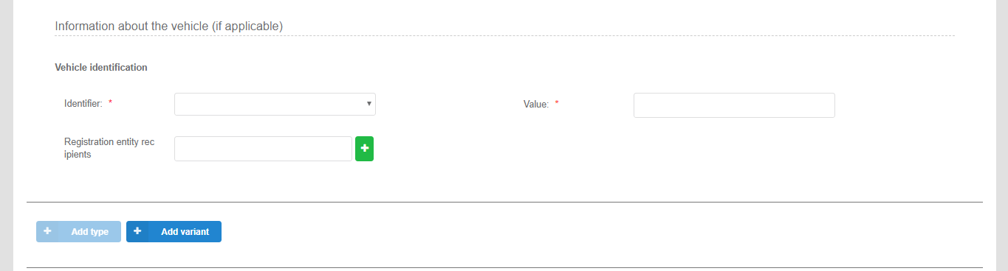
Figure 74: Information about the vehicle

For the combined authorisation cases offered by the system, “First Authorisation and Authorisation in conformity to type” and “New Authorisation and Extended area of use authorisation” the user must introduce the required information for both authorisations requested, as shown in Figure 75.
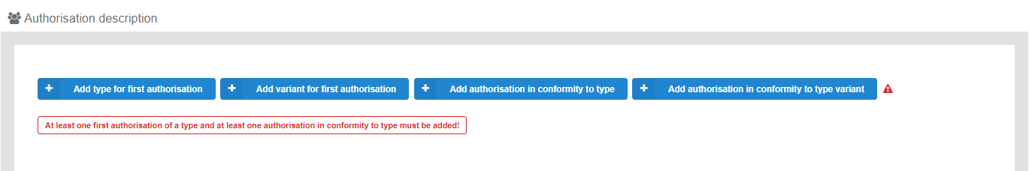
Figure 75: Authorisation Details – Combined Authorisation case for FIRST+CONF

The applicant may provide also, the relevant information about the description of a vehicle type. The user may fill in the Type ID and the type name of the vehicle. Also, he can delete the type, if he selects the (-) button.

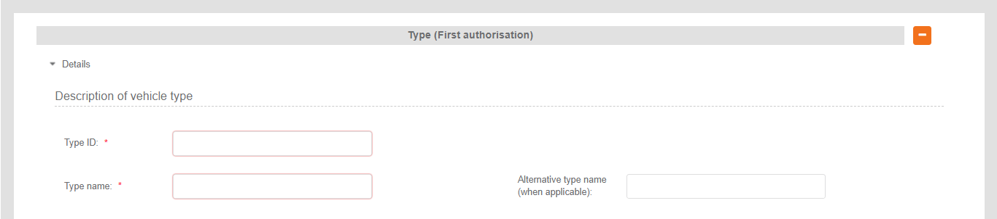
Figure 76:Description of vehicle type (First authorisation)
The last step in this Authorisation details step is the selection of the “Issuing Authority”. If the Applicant has introduced a number of Member States, within the Type/Variant(s), then the system sets this value automatically to “European Union Agency for Railways”, as shown in Figure 77. The applicant may choose to use the “National Safety Authority”, only if all introduced Type/Variant(s) address one and the same Member State, in which case the Member State is the issuing authority.
Figure 77: Issuing Authority
To move to the next step "Save & next step" is selected as shown in Figure 66, the form is saved. In addition, the system allows the user to visit the previous step of the wizard by selecting “Previous step” button, shown in Figure 41.

Documentation
In this step of the wizard as shown in Figure 78, the Applicant must provide the documentation relevant to the Authorisation case selected in the first step. The list of folders as appear in this step stem from Annex I of the implementing act (Commission Implementing Regulation (EU) 2018/545 of 4 April 2018 establishing practical arrangements for the railway vehicle authorisation and railway vehicle type authorisation process).

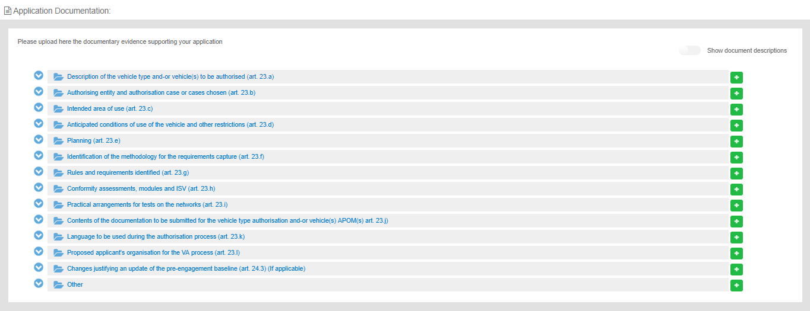
Figure 78: Application documentation
The Applicant can upload any documents needed for the application by selecting the "+" button relevant to each folder. Such action displays the Add file(s) page, shown in Figure 79 and allow the user to either select one or more files to upload from a specific folder on the user’s system as shown in Figure 80 or by drag and drop the file(s) in the “Drop your file(s) here” section. Please note that the system accepts as valid uploads the ones described in the File upload rules.
Figure 79: Add file(s)
Figure 80: Choose file(s)
Figure 81: Successful upload
When selecting "Add file(s)" the file(s) selected by the user are uploaded and if successful the messaged displayed in Figure 81 is shown and the relevant file(s) appears in the relevant folder of documentation, as shown in Figure 82.
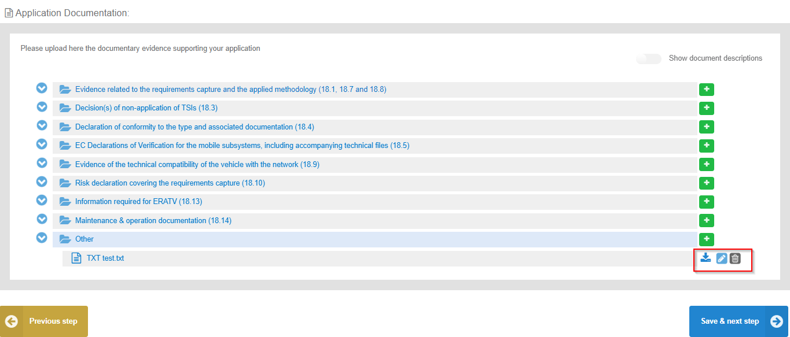
Figure 82: Uploaded file

The user can download and delete the document by using the relevant buttons on the right and also edit the title and the description of the uploaded file.
Figure 83:Edit button- Document info
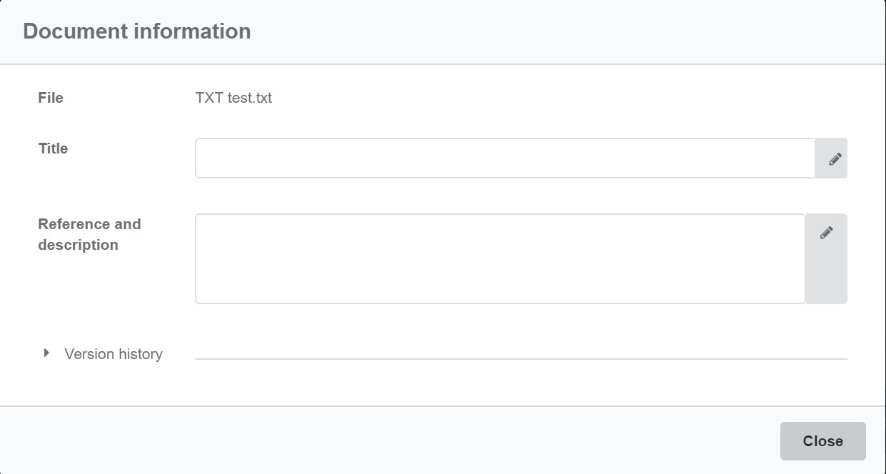
Figure 84: Document information
The user can select the “Show document description” button and then the system displays the details of the uploaded file e.g. the size, the title of the document and the description.

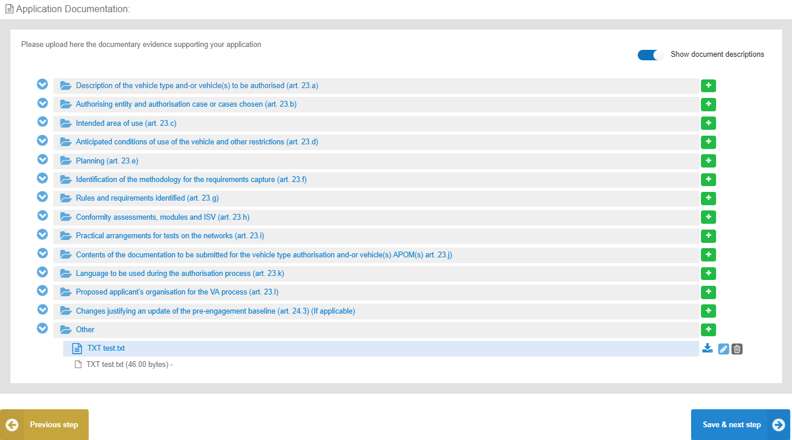
Figure 85: “Show document descriptions” button
To move to the next step "Save & next step" is selected as shown in Figure 66, the form is saved. In addition, the system allows the user to visit the previous step of the wizard by selecting “Previous step” button, shown in Figure 41.

Sign & submit application
In this last step of the wizard the user can review the application form prior to submitting it, as shown in Figure 86.
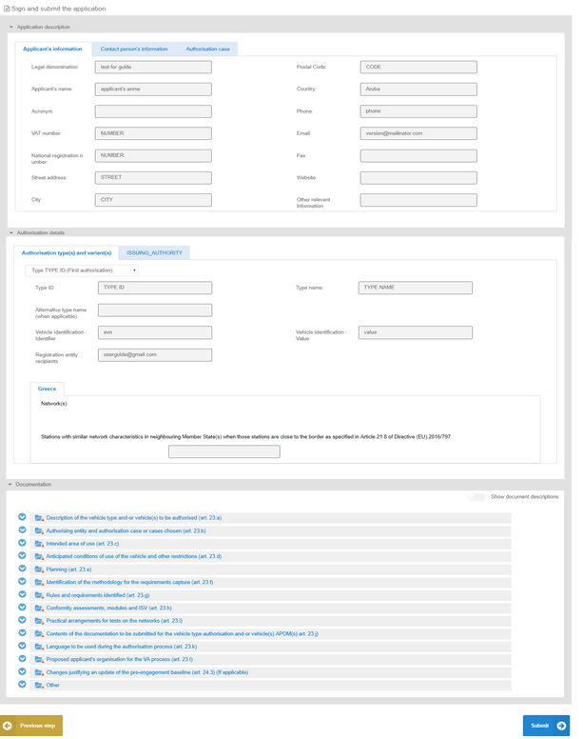
Figure 86: Review application

The application form is presented in read-only mode, any changes can only be made in the relevant sections of the application form. To go back to the previous step, select “Previous step” as shown in Figure 41. To submit the application, select "Submit".

Share application
In the “Main page – Application list”, select the option to share an application with another applicant user. Select option “Share application”, as shown in Figure 87, fill in the requested information in the popup window that is displayed, as shown in Figure 88, and finally select “Share”. A notification will be sent to the new application user.

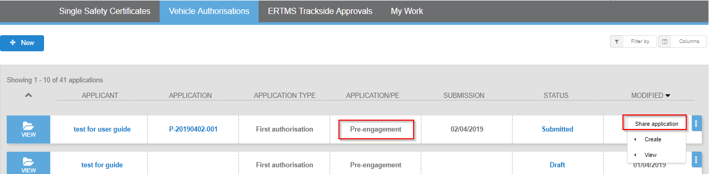
Figure 87: Share application

Figure 88: Share application – popup

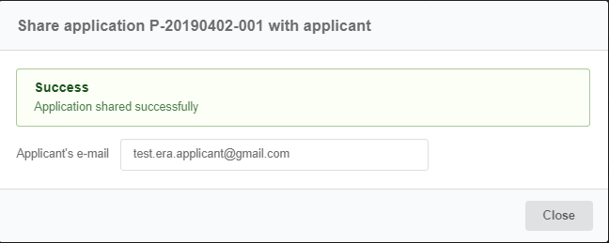
Figure 89: Successful message for “Share application”

My work
When the user logs in to the system OSS, he can navigate to the “My work” section in order to view his Issues and Notifications as shown in Figure 90.
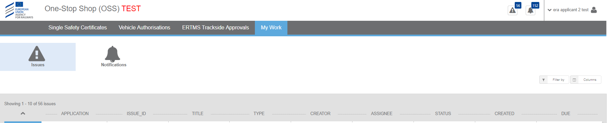
Figure 90: “My Work” screen
“Notifications” tab:
The OSS sends notifications to its users according to specific events and business rules. Notifications can be both in-app and via email.
The user can view all the notifications that concern him if he clicks on the “Notifications” button. Then the system displays all notifications for changes that have been made, for example, the submission, the creation of a new issue, the update of an application etc. All users can configure if they are receiving notifications also by email through user profile menu (in-app notifications are sent by default).
If the user wants to see the details of a notification, he selects “View” and the system displays the below pop up window:
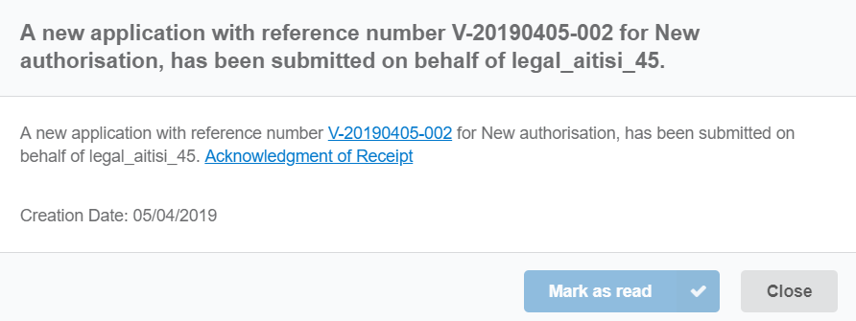
Figure 91: Details of a notification
If the user selects “Mark as read” the notification is grey out. The unread notifications count number (Figure 15) is updated when a notification is marked as read. Also, the user can close the pop-up window that the system displays, if he clicks on “Close” button.
All lists allow for filtering and sorting (Figure 12).
“Issues” tab:
Issues are created in order to support the communication between the assessment team and the applicant.
“Issues” tab allows the applicant to view the list of issues across the applications. If the applicant selects “View”, then he can view/update/submit the issue. All lists allow for filtering and sorting (Figure 12). Issues can be viewed by clicking on “Issues” button as shown in Figure 14.

Application Details Screen
When an applicant logs in his or her account, the system displays his/her application list. If the applicant selects to “View” his/ her application, the system displays the below screen:
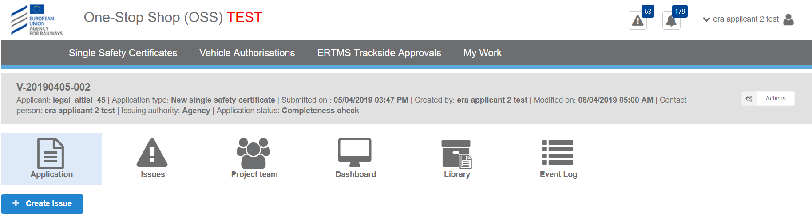
Figure 92: Details of application
In this section there are the below tabs:
Application: The applicant can view the application in read only mode as shown in Figure 93.
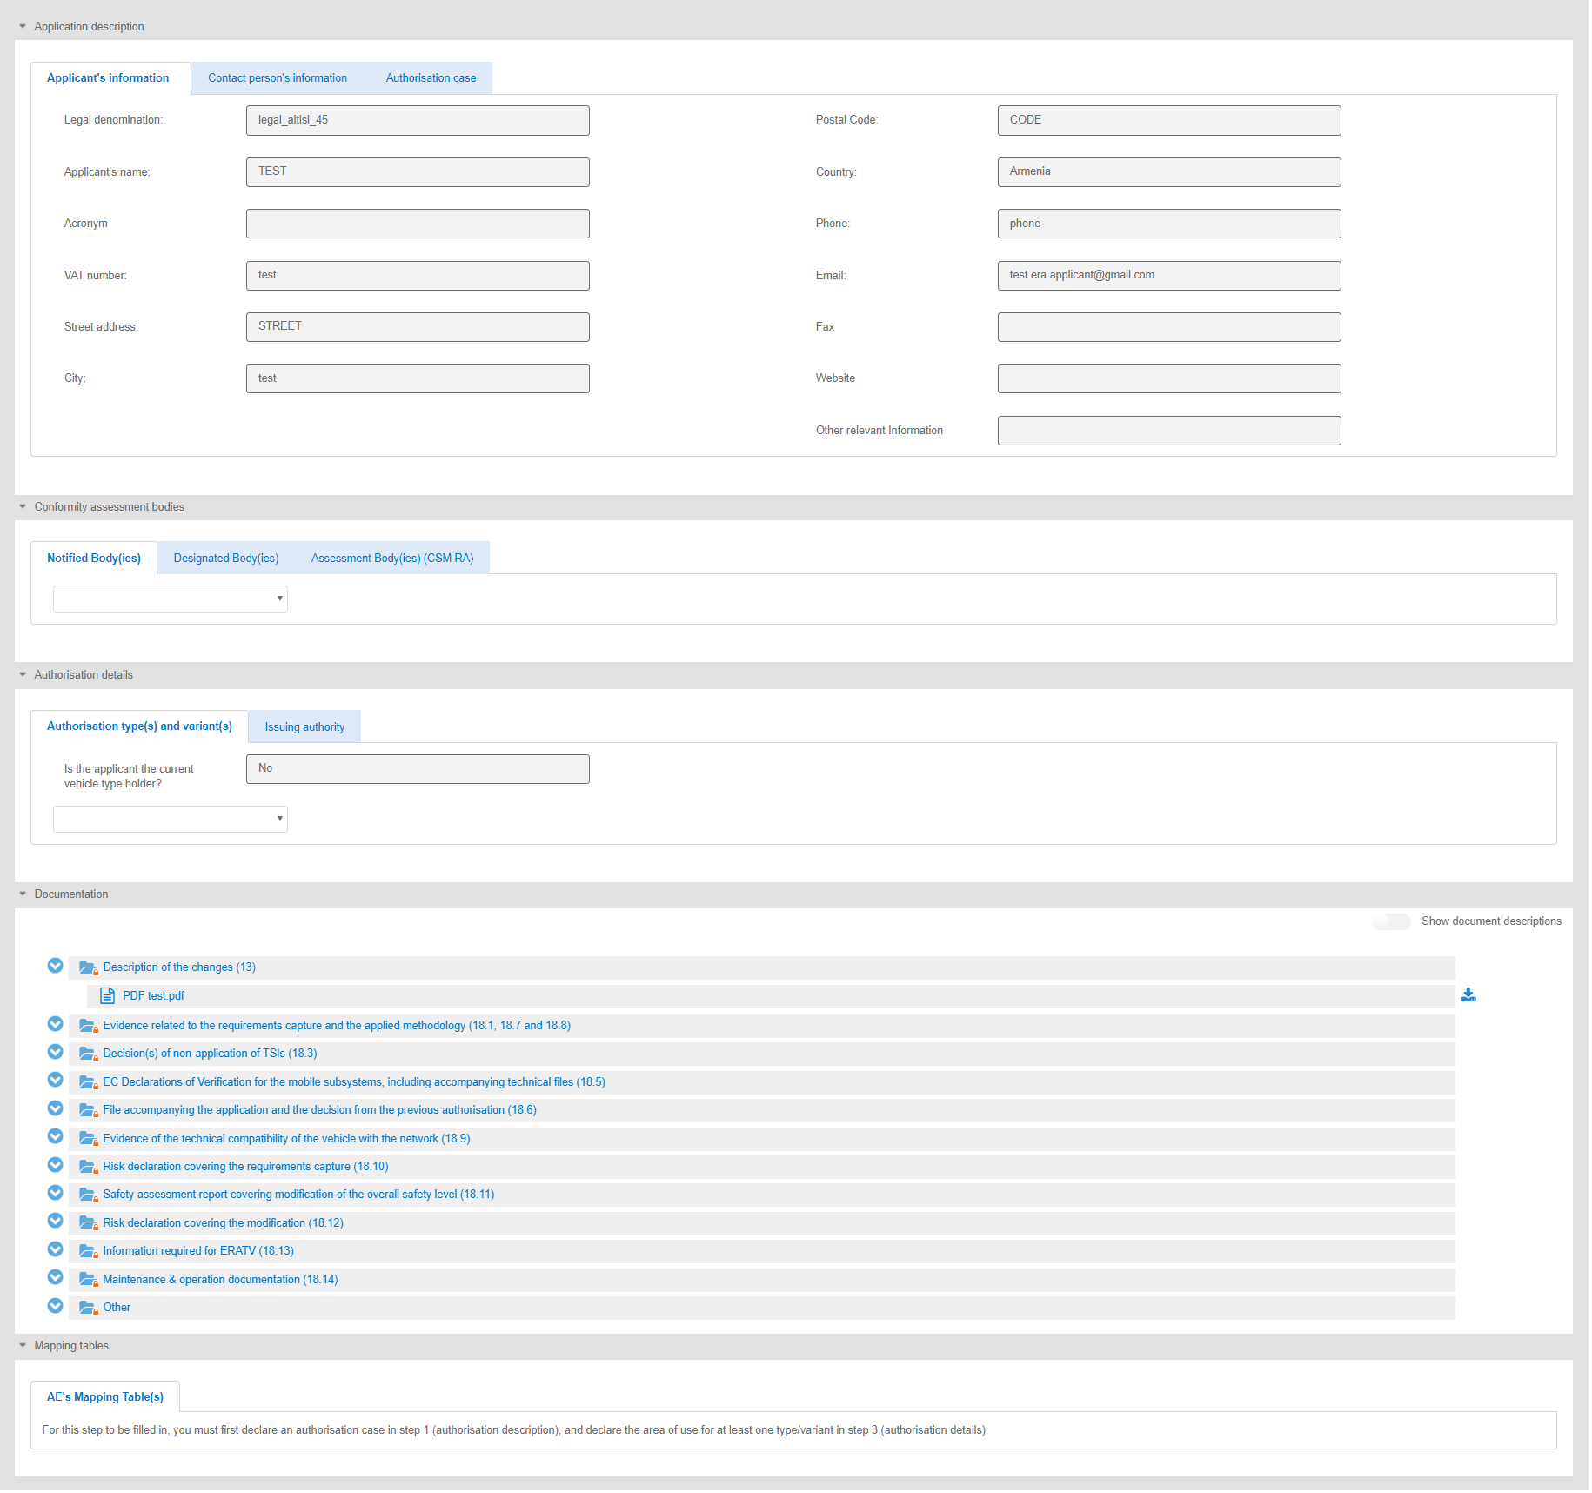
Figure 93: “Application” tab in read only mode by the applicant
Issues: In this tab, the applicant can view the list of the issues which are assigned to him/her or which are created by him. The issues are created in order to support the communication between the assessment team and the applicant. Also, he/she can update an issue which is assigned to him/her. The applicant can also view an issue by selecting the Issues button as shown in Figure 14. To create an issue and more information for the Issues, see the Chapter 7.
Project team: Τhis tab can only be filled in by the Programme Manager (PGM). The PGM may select the team members for an application or update/ change an already assigned team. The specific application roles (Project Manager, Assessor, Assuror, Decision Maker, Observer) are assigned/unassigned to the users by the respective PGM during the application process.
The applicant can only view the assessment team in the Project team screen, which is responsible for the submission of the reports of his application.
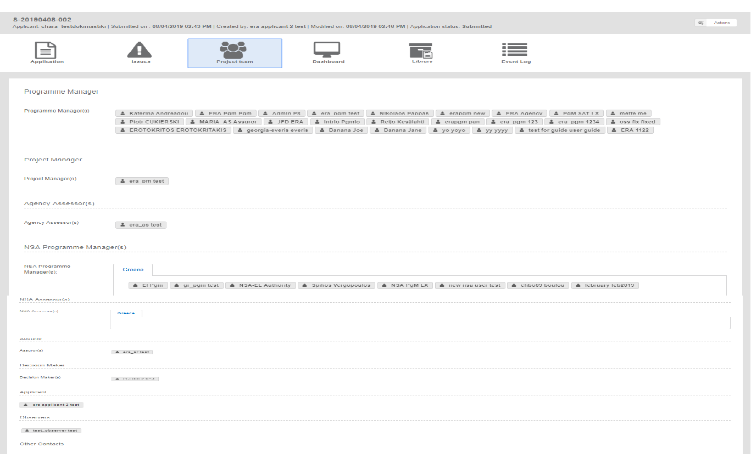
Figure 94:” Project team” tab in read only mode by the applicant
Dashboard: The Dashboard/milestones is the main tool for managing and communicating the important dates (milestones) of each project/application, as well as the application status. The application status is calculated automatically or changed by the Project Manager. Each milestone is usually defined by a planned and an actual date. The only role can edit or change the milestone dates is the Project Manager (PM). All other roles, so and the applicant, have a read only view to the schedule as shown in Figure 95.
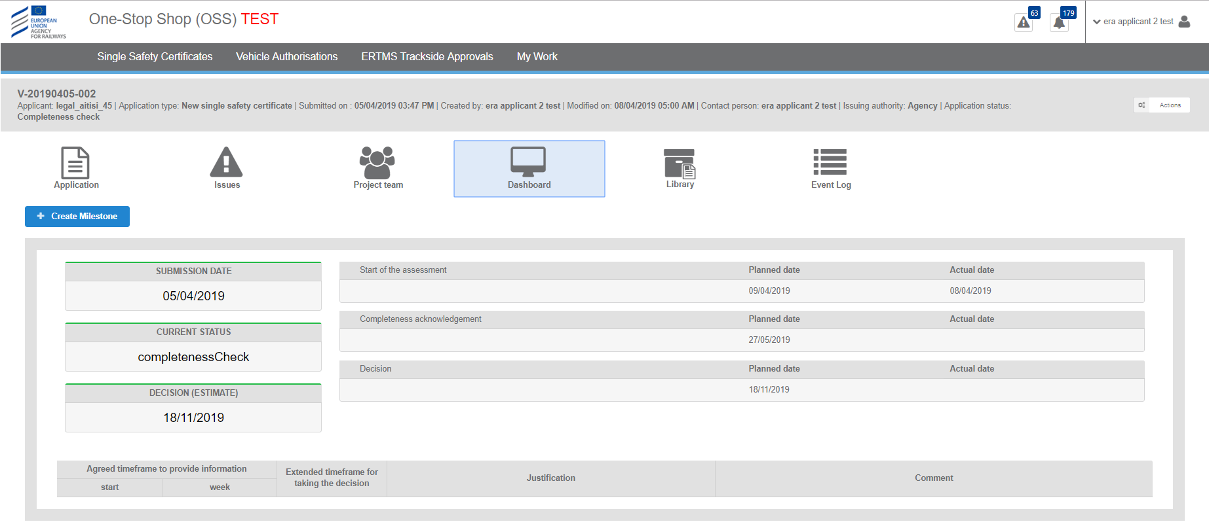
Figure 95: Dashboard screen
Library: The library is the repository where all application information is stored. It contains all documents uploaded by the users, together with their watermarked pdf version (both for the application file and the assessment file) as well as links to and watermarked pdf versions of all web forms. The library information and functionality can be accessed according to the user’s access rights.
- Browse application information through a tree-like structure of folders and follow links to view/download documents.
- Upload documents.
- Update / append a new version to an existing document (same principles as above apply).
- View past versions of documents.
- Delete documents (when application status = draft).
- Mark documents as invalid (by the assessment team only when application status ≠ draft, and by the applicant during an application update).
- Search for documents/information (details in the next section).
- Export application.
- Update the library structure.
- Switch between viewing the latest version of the library/documents and the initially submitted one (actually the submitted application file).
- Revert to a past version of a document
- View history log with all user actions on the documents/information
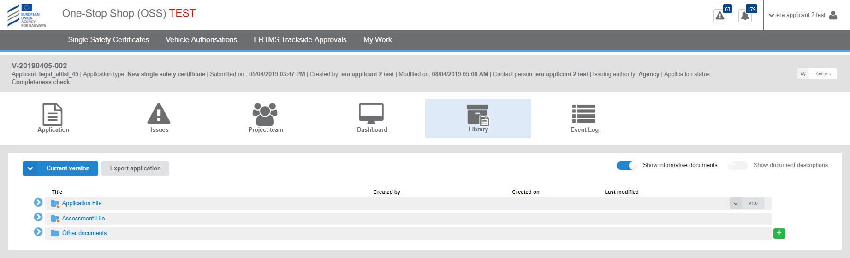
Figure 96: “Library” screen
The relevant user can upload files by clicking on the + button in the relevant folder as shown in Figure 96. The upload files process is described in paragraph 3.5.
After the uploading, the user can see the details of the file, as shown in Figure 97, by clicking on the “Show documents description” radio button or can download a file by using the “Download document” button as shown in Figure 98.
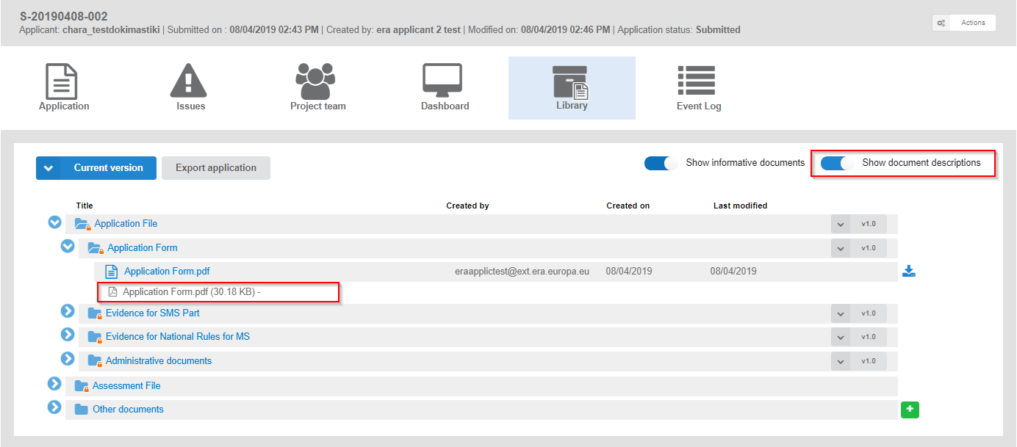
Figure 97: “Show document descriptions” radio button
The applicant can also download a document selecting the “Download” button.
Figure 98: “Download” button
The applicant can select the version of the uploaded document.
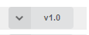
Figure 99: “Select version” button
The applicant can also select the files the can see on the Library screen. If the user selects the option “Initial application version”, he can view only the uploaded files until the submission of the application.
If the user selects the option “Current version”, he can view all the uploaded files that have been added to this current version from the time of submission and after.
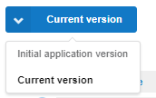
Figure 100: “Current version” button
If the user selects the “Export application” button as shown in Figure 101, the system downloads all uploaded files of the application in a zip folder.
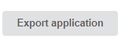
Figure 101: “Export application” button
Event log: The event log is a detailed list of a user actions during the lifecycle of an application. The events log exists only after application submission. The following are captured in the log:
- Change of application status
- User actions(tasks/actions)
- Creation/update/closure of issues
- Upload/update of documents/reports (after application submission)
- Assignment/update of the assessment team
- Update application file
Each record in the log contains the following information:
- Timestamp
- User
- Role
- Action/event
- Details
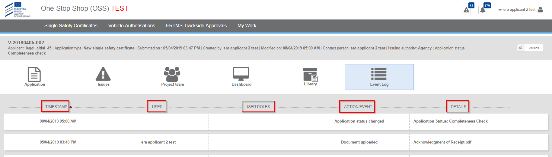
Figure 102: Main screen of event log
Events log which concern Issues, can be found in the Issue form. (Figure 103).
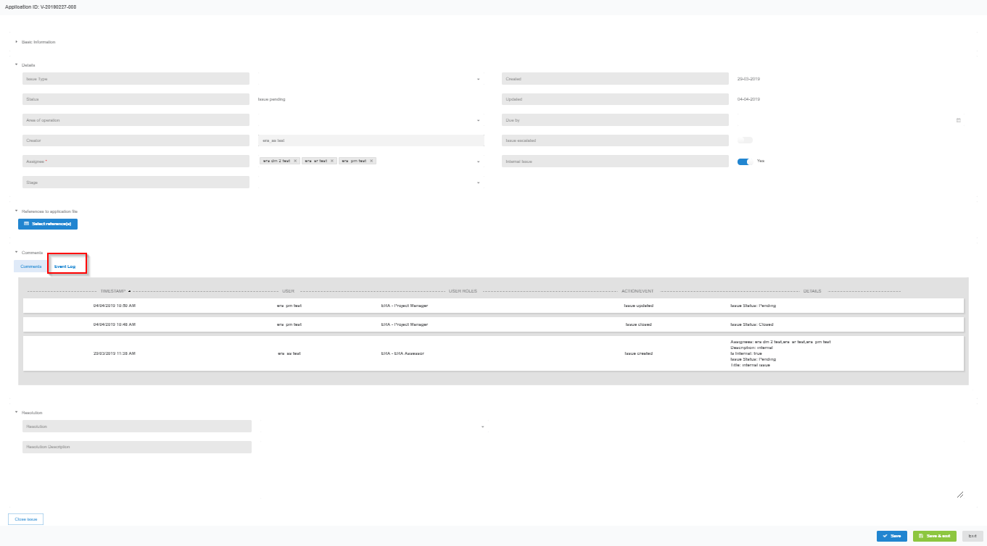
Figure 103: “Events log” for the issues
“Actions” button: Terminate application- Request Review
If, despite the early warning, the application is submitted to the one-stop shop (OSS), the authorising entity is invited to contact the applicant and seek more information. Depending on the explanations provided by the applicant, the authorising entity may reject the application or terminate the application upon request of the applicant. So, if the applicant wants to terminate his application he can select from the “Actions” button from the application details screen, the option “Terminate application” as shown in Figure 104.
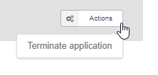
Figure 104: Actions button- Terminate application
If the applicant receives a notification for the submission of the Opinion report, he can select from the “Actions” button the option “Request review” as shown in Figure 105. If the Opinion is a refusal, the applicant may request that the authorising entity review its Opinion. The applicant is obliged to request a review before it can appeal against the Opinion of the authorising entity. This process is activated in order to repeat the Opinion report.
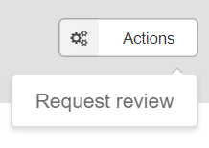
Figure 105: Actions button- Request Review

Communication between applicant and assessment team-Issues
Issues is the main tool used by the assessment team Project Manager (PM), Assessor (AS), Assuror (AR), Decision Maker (DM) and the applicants to communicate during the assessment process of a case. Issues are created:
- By the assessment team to raise a problem during the assessment process, asking the applicant to provide evidence for resolving it,
- By the applicant to communicate with the assessment team
- By the assessment team and addressed to the assessment team, e.g. to communicate differences of opinions or disagreements.

Update an application file
This allows the update of the specific application requirement by the applicant in response to an issue that was raised by a member of the assessment team. The update of the application file will be done by the Applicant in the same way he had submitted it by updating the web forms. Also, the applicant can request the resolution or closure of an issue to declare he has completed the update of the application file (status=responded). In this status the application file is locked, and no update is anymore possible.
If, the applicant wants to view his notifications, he selects the “Notifications” button as shown in Figure 15. If he has received a notification for an Issue, he has to update his application.
Then, the applicant can open the notification and selects to view the issue selecting the provided link which is assigned to him as shown in Figure 106. He selects to view his application in VA or VA PE. He can update the application only in the sections which are selected from the creator of the issue. Finally, the applicant selects to save and to submit again the application and clicks again on “View” tab of the issue in order to select the “Request issue resolution” button as shown in Figure 107. Then the status of the issue is changed to responded (pending=responded).

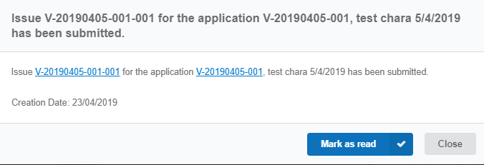
Figure 106: Notification for the applicant to update his application
Figure 107: Request issue resolution button
If the applicant does not provide the requested information, or if the supplementary information provided by the applicant is not satisfactory, the timeframe of the assessment may be extended, or an application can be rejected. Rejecting an application is the last resort, and when the safety certification body decides to do so the decision and the reasons for it are recorded in the assessment report and notified to the applicant. Any rejection decision requires a re-submission of the application.

Create issue by the applicant
After the submission of an application, the applicant can raise an issue and address it to the Project Manager (PM) in order to ask a question about the assessment of the application file or to request the update of the application file.
He navigates in his application, clicks on “View button” and after clicks on “Create issue” button as shown in Figure 108. The system displays the Issue’s screen as shown in Figure 109 and he provides all the mandatory information e.g. the issue title, the description for the issue etc. Finally, if he wants to save the information, he selects to “Save” the issue or selects the “Save and Exit” button. Then the status of the issue is draft. In order to submit the issue, the applicant selects the “Submit” button and the status of the issue is pending. Only, after the submission of the issue, it is visible to the Project Manager (PM).

Figure 108: Create Issue button

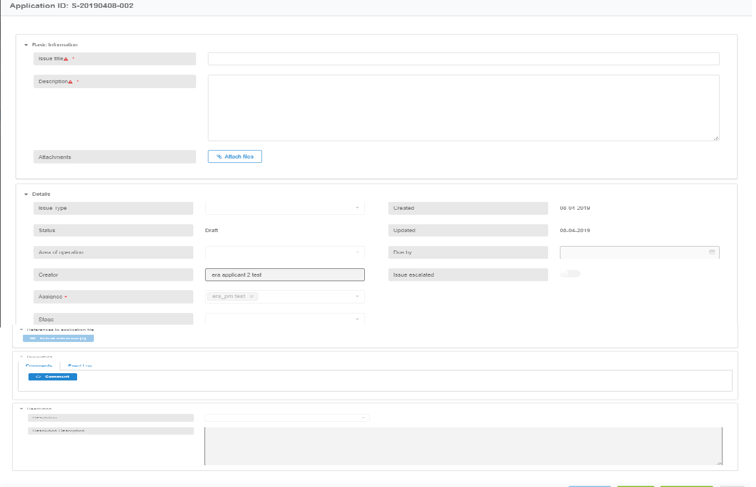
Figure 109: Create issue form
The applicant can only view the issues he created or issues that are assigned to him. An issue that is created by the applicant can be initially assigned only to the Project Manager (PM).

